Logo****

UNIVERSITY OF SOUTHAMPTON

ACADEMIC YEAR 2017/2018

FACULTY OF NATURAL AND ENVIRONMENTAL SCIENCES

SCHOOL OF OCEAN AND EARTH SCIENCE

**THE TEMPORAL EVOLUTION OF INTERIOR CARBON STOCKS OF SOUTH GEORGIA**

by

**Evelyn May Byer**

A dissertation submitted in partial fulfilment of the requirements for the degree of M.Sc. Oceanography by instructional course SOES 6039 MSc Research Project.

# Supervisor’s signed statement

As the nominated University supervisor of this M.Sc. project by Evelyn May Byer, I confirm that I have had the opportunity to comment on earlier drafts of the report prior to submission of the dissertation for consideration of the award of M.Sc. Oceanography.

Signed...............…………………........................

Supervisor’s name: Dr. Filipa Carvalho

Table of Contents

Supervisor’s signed statement i

Acknowledgements v

Abstract vi

1. Introduction 1

1.1. Seasonal evolution of particulate organic carbon 2

1.2. Particle sinking and attenuation 4

1.3. The Southern Ocean and South Georgia 5

1.4. Common methodologies 6

1.5. Objective and aims 7

2. Materials and methods 8

2.1. Study area, platforms and sensors 8

2.1.1. South Georgia and Station P3 8

2.1.2. Red Camera Frame 9

2.1.3. WET Labs ECO Triplet, RBR Concerto, and Seabird CTD 10

2.2. Data analysis 10

2.2.1. Physical variables analyses 10

2.2.2. Optical calibrations 11

2.2.3. Optical baseline analyses 12

2.2.4. Optical spike analysis 15

2.2.5. Spike frequency attenuation 16

2.2.6. Estimating POC flux 17

3. Results 19

3.1. Oceanographic setting 19

3.2. Temporal evolution of chlorophyll a concentration 22

3.3. Temporal evolution of particulate organic carbon concentration 22

3.4. Analysis of backscatter spikes 27

3.4.1 Temporal evolution of spike frequency attenuation 27

3.4.2. Attenuation of spike frequencies across platforms and noise thresholds 27

3.5. Estimated POC flux 32

4. Discussion 35

4.1. Oceanographic setting: comparison with the literature 35

4.2. Bloom dynamics and carbon export in South Georgia 36

4.3. Comparison of particle attenuation and flux estimates 38

4.4. Possible nature of spike-causing particles 44

4.5. Project limitations and future work 44

5. Conclusions 46

A. Bibliography 47

B. Appendix 53

B.1. Deployment tables 53

B.2. MATLAB script 57

# Acknowledgements

This project and my education in this master’s program was greatly enhanced by my supervisor, Filipa Carvalho, who went over and beyond to help me learn MATLAB programming and guide this project. Other members in the same lab were also indispensable in this dissertation: thank you to Nathan Briggs for assistance with analysis of optical data, Stephanie Henson for giving feedback on the project, and Sari Giering for assisting with my final presentation. I would also like to thank my family and friends for supporting me from halfway around the world. Last but not least, I would like to thank my late grandfather, Dr. Robert Thomas Linger, Sr., for ultimately making this experience possible for me. *I’m doing mighty fine*.

# Abstract

The ocean can act as a sink of carbon dioxide from the atmosphere. One of the most important mechanisms of ocean carbon uptake is the biological carbon pump. This pump describes the process in which phytoplankton converts CO2 into organic carbon in the surface ocean. Particulate organic carbon can then sink out of the mixed layer into the mesopelagic zone where it could be remineralised back into CO2 and escape back to the atmosphere. Alternatively it can continue to sink eventually entering the deep ocean. Once carbon has reached the deep sea, it can stay trapped there for hundreds of years, effectively hiding from the atmosphere. This process mitigates anthropogenic climate change. Our understanding of the dynamics of carbon is hindered by logistical and technological hurdles of quantifying the intrannual variability of carbon dynamics in the mesopelagic. Optical proxies are a promising new way to measure the seasonal evolution of carbon in the water column. In this dissertation, high resolution optical data collected on cruise DY086 in November and December 2017 is used to determine the temporal evolution of interior carbon stocks in South Georgia. In the surface layer, chlorophyll a and POC concentration decreased over the time period of the cruise, with evidence of a flux event occurring at the end of November. Backscattering spike frequencies, used as a proxy for large particles in the water column, had attenuation coefficients ranging from 0.51-1.77 (95% C.I.) depending on phase of the bloom, methodology, and platform used. Particulate organic carbon flux was estimated to range from 144-285 mg C m-2 d-1 (95% C.I.) at 200 m. Comparisons of optical spikes obtained using different platforms and methods suggested that the magnitude of optical spikes is sensitive to either platform type, velocity of the optical sensor or both. Conversely, optical spike frequency attenuation with depth appeared to be less sensitive to methodological differences. This suggested that optical spike data is not comparable across different methodologies, depending on analysis type. Nevertheless, attenuation coefficients and flux estimates compare reasonably well with literature values from the same region or similar methods, suggesting it is a robust method of describing interior carbon dynamics. Future work should focus on fully understanding the impact of platform type and sensor velocity on optical spike data, as well as incorporating sediment trap data from cruise DY086 into the calculations provided in this project.

# 1. Introduction

The ocean plays an important role in the carbon cycle and can act as a sink of carbon dioxide (CO2) from the atmosphere. One of the most important processes of oceanic carbon uptake is the biological pump (BCP). The BCP is described as the process in which inorganic carbon in the surface ocean is converted into organic carbon and exported to depth where it can stay isolated from the atmosphere for hundreds of years (Figure 1). Without the BCP, atmospheric CO2 levels would be about 200 ppm higher than current concentrations (Kwon *et al.*, 2009). Quantifying the attenuation and flux of particulate organic carbon (POC) with depth is an important element to accurately modelling the global carbon cycle. The magnitude of remineralisation that takes place in the mesopelagic is particularly important, as even small changes in the remineralisation depth has been shown to exert considerable control on atmospheric CO2 concentrations in modeling studies (Kwon *et al.*, 2009). Fully understanding these parameters is paramount to making accurate predictions of future atmospheric carbon dioxide levels (Kwon *et al.*, 2009; Henson *et al.*, 2015). Further complicating the study of carbon dynamics in the mesopelagic region is seasonal variability of POC (Gardner *et al.*, 2000; Dall'Olmo and Mork, 2014; Henson *et* *al.*, 2015). The temporal evolution of carbon in the interior ocean is insufficiently understood, adding further uncertainty to any global or regional estimates of oceanic carbon uptake.

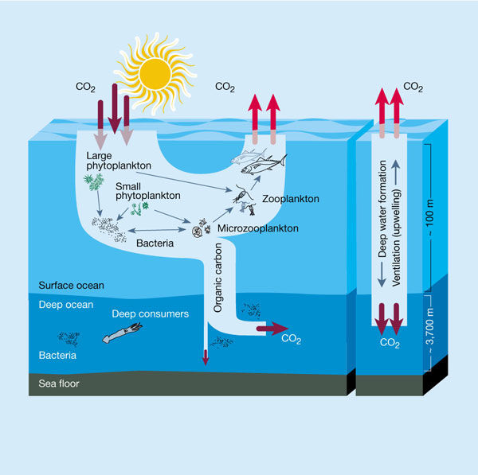

**Figure 1. The biological carbon pump.** Phytoplankton convert CO2 into organic carbon in the surface ocean. The majority of this carbon is respired back into CO2 before reaching the deep ocean, but the fraction that escapes remineralisation can be transported to depth. The net result is a transfer of carbon from the atmosphere to the deep ocean where it can remain effectively hiding from the atmosphere for hundreds of years. Figure from Chisholm (2000).

## 1.1. Seasonal evolution of particulate organic carbon

In areas with a strong seasonal signal in primary production, a general pattern of POC can be described (Gardner *et al.*, 2000). This temporal evolution can be divided into three main stages. The first stage is characterised by a rapid increase of primary producers and organic carbon in the upper layer. Biomass accumulates and losses from the surface layer are very low, due to the fact that grazers have a slower growth rate than primary producers and particle aggregation typically lags. The second phase consists of a stabilization of net growth of primary producers in the upper layer (through nutrient limitation or grazing pressure) coupled with enhanced sinking rates of POC. Finally, in the third stage stratification weakens, POC declines and organic carbon stocks decrease in the surface ocean. Though general patterns have been described the seasonal variability of POC in the interior ocean continues to be so poorly understood that even the magnitude of temporal variability is not well constrained (Henson *et al.*, 2012).

Previous research focused on understanding the dynamics of particulate organic carbon in the water column has focused on using models (Anderson and Tang, 2010), estimating the rates of microbial and zooplankton respiration (Steinberg *et al.*, 2008), carbon mass balance (Giering *et al.*, 2014), and observing patterns of particulate matter flux with depth (Martin *et al.*, 1987; Buesseler *et al.*, 2007). These studies offer a temporally and spatially limited snapshot of the system, yet can be used to estimate total annual carbon export (Laws *et al.*, 2000; Henson *et al.*, 2011). In this case, the studies make the necessary assumption that the relatively brief time period of data collection is representative of the annual mean and processes affecting carbon in the mesopelagic do not significantly vary throughout the year. With empirical algorithms on BCP efficiency in models derived from this limited in situ data, it is difficult to test whether they accurately represent the BCP.

The seasonal evolution of POC could be a missing puzzle piece in studies that have failed to close the carbon budget in the mesopelagic. Carbon mass balance is based on a steady state assumption where the carbon demands of organisms in the mesopelagic should be equal to or less than the supply of carbon entering the system (Steinberg *et al.*, 2008). However, in reality carbon supply and carbon demand in the mesopelagic are nowhere close to being balanced. This highlights our lack of understanding of carbon dynamics and processes that ultimately determine how much carbon the ocean can uptake from the atmosphere.

Model studies have shown that assuming steady state when the system was actually in non-steady state could result in underestimating the particulate organic carbon flux to the mesopelagic (Giering *et al.*, 2017). One study was able to demonstrate a match between carbon supply and demand in the twilight zone using neutrally buoyant sediment traps, but it was later determined that temporal variability could apply substantial uncertainty in the original estimates (Giering *et al., 2014;* Giering *et al.*, 2017). Ignoring temporal variability leads to misinterpretation of particle flux profiles when input fluxes from the upper ocean vary on the order of weeks, such as is found in temperate and polar regions with strong seasonal cycles in export.

## 1.2. Particle sinking and attenuation

The biological carbon pump acts as a carbon sink principally through transferring POC from the surface ocean through the mesopelagic via gravitational sinking of POC (Kwon *et al.*, 2009). The fraction of POC leaving the upper ocean that ultimately reaches the deep sea depends on particle sinking speed and rate of remineralisation. Together, these two rates define the remineralisation depth (Kwon *et al.*, 2009). POC sinking speed can be placed into three categories: fast sinking (> 20 m d−1), slow sinking (< 20 m d−1), and suspended (Riley *et al.*, 2012). Fast sinking POC is typically considered to be the most important, concerning flux into the deep ocean, as slow sinking particles spend a longer time period in the mesopelagic and are more likely to get remineralised at shallower depths (Buesseler *et al.*, 2007).

However, the divide between fast and slow sinking particles is not black and white. POC can transfer between fast sinking, slow sinking, and suspended pools, but this transfer is not well represented in models. Slow sinking POC has been cited as the largest sinking POC pool in the some regions (Baker *et al.,* 2017). Particularly in the Southern Ocean, slow sinking POC was shown to be generated in situ below the mixed layer during the seasonal bloom as a result of particle fragmentation (Baker *et al.,* 2017). This could contribute to high attenuation of fast sinking particles in the water column in this region. With this in consideration, slow sinking POC may penetrate deeper into the water column in the Southern Ocean than is currently parameterized in models. Likewise, fast sinking particles may degrade shallower than is currently modelled. Thus, models may overestimate the importance in POC to carbon storage because they do not accurately account for fragmentation or shifts between particle pools (Baker *et al.*, 2017).

The relative difference in particle sinking rates has proven to be a significant factor in the variability of carbon stock in the mesopelagic at any one time, affecting POC flux and attenuation observations. Omitting gravitational POC sinking, fragmentation and transfer between POC pools may cause uncertainties in organic carbon mass balance calculations in the mesopelagic. In the study mentioned earlier by Giering *et al.* (2017), a neutrally buoyant sediment trap was used to measure flux and found that POC flux increased with depth. They compared this data with data from a continuous plankton recorder nearby. One diatom that was only present in surface waters in the beginning of the bloom season, *Bacteriastrum*, then disappeared from the surface ocean and took three months to be collected at depth. Other species were found to sink at much faster rates. Thus, their results provide evidence that temporal variability in observed POC flux and attenuation is likely to be highly dependent on surface community structure and POC sinking rates.

As organic particles sink through the mesopelagic zone, metabolic processes associated with heterotrophic consumption results in a decrease in flux with depth (Buesseler *et al.,* 2007). The rate at which this attenuation occurs with depth is often characterised by a curve fit to a power law, first proposed in Martin *et al.* (1987) from sediment trap flux observations in the Pacific. This function links the flux at depth z to the flux at the base of the euphotic zone (z0), F(z0), and is equal to F(z) = F(z0)·(z0/z)-b. The exponent, b, has become known as the attenuation coefficient and the equation referred to as the Martin curve. The magnitude of the b-value describes the steepness of particle attenuation in the mesopelagic zone, with a higher magnitude b-value equating to a steeper slope (increased attenuation of particles with depth).

In high latitude systems with a strong seasonal signal, b-values are likely to vary intrannually. However many of the current estimates of *b* are based on globally modelled data sets or observations made in the Pacific (Sanders *et al.,* 2014). This highlights the necessity for increased estimates of particle attenuation in regions hypothesized to have disproportionately large importance in ocean carbon uptake such as the Southern Ocean.

## 1.3. The Southern Ocean and South Georgia

The Southern Ocean is thought to comprise about 40% of the global ocean anthropogenic CO2 uptake (Sabine *et al.*, 2004; Frölicher *et al.*, 2015). This zone is largely a high-nutrient low-chlorophyll region (HNLC), limited by iron availability (Martin *et al.,* 1990a; Martin *et al.,* 1990b) and solar radiation. However, iron input from oceanic islands and melting sea ice can cause intense phytoplankton blooms, which may lead to large POC export (Pollard *et al.*, 2009). In contrast to the HNLC conditions of much of the Southern Ocean, located on the northern border is the South Georgia bloom which is one of the largest and most sustained open ocean phytoplankton blooms on the planet. It can last from four to six months (Korb *et al.*, 2004) and is comprised of mostly large colonial diatoms (Atkinson *et al*., 2001). These blooms seed the ocean downstream for hundreds of kilometres which is associated with the highest estimated carbon export in the Southern Ocean (Schlitzer, 2002). Although the region is characterised by massive phytoplankton blooms and is estimated to be a large sink of carbon from the atmosphere, the seasonal evolution of interior carbon stocks near this island remain largely unresolved. Bio-optical proxies have the potential to fill in the knowledge gaps in the temporal variability of carbon in this region.

## 1.4. Common methodologies

Knowledge of the seasonal evolution of interior carbon is limited due to logistical constraints. Additional methods to those mentioned in section 1.1 used to measure carbon attenuation and flux include the f-ratio (Eppley and Peterson, 1979), 234Th-SST method (Henson *et al.*, 2011), inversion of nutrient data (Schlitzer, 2004), and sediment traps (Lampitt and Antia, 1997; Giering *et al.*, 2014). Studies using these methods have produced global carbon export values which range from about 5-12 Gt C yr-1 (Henson *et al.*, 2011) emphasizing our incomplete knowledge of the oceanic carbon cycle. As these studies require an enormous investment in ship time, broad spatial coverage in observations of particle patterns is only available at a few sites. Long-term temporal coverage is only found at a handful of time-series sites (Estapa *et al.*, 2013).

Promising new technologies are likely to fill in temporal and spatial data gaps in the oceanic carbon cycle. Bio-optical variables measured by sensors deployed on ship-based and autonomous platforms have the potential to estimate POC dynamics and characterise particles (Cetinić *et al.*, 2012). However, the challenge with utilising bio-optical properties is converting from raw data to quantification of carbon and then determining the underlying processes driving observed patterns.

Several studies have already successfully gathered high-resolution data of particle attenuation and flux as well as inferred the drivers of changes in POC using optical sensors (Briggs *et al.,* 2011; Estapa *et al.*, 2013; Dall'Olmo and Mork 2014; Estapa *et al.*, 2017). For example, Briggs and colleagues (2011a) gathered high-resolution observations of aggregate flux in the North Atlantic using backscatter spike data measured by four autonomous gliders. Their carbon export compared well with independent carbon export estimates from the same project. Specifically, the study showed that spikes in measurements of particulate backscattering coefficient (bbp) and chlorophyll a fluorescence can be interpreted as aggregates below the mixed layer. Thus, optical spikes have the capability to provide high resolution measurements of aggregate flux events (Briggs *et al.,* 2011a).

An incomplete understanding of the seasonal evolution of interior carbon has major repercussions in modelling the carbon cycle and predicting future atmospheric carbon dioxide concentrations. Despite its importance, the magnitude of this variability is still not understood or fully quantified because of a major deficit of in situ data. The methodological development of using bio-optical measurements as proxies for POC promises high-resolution data that can be collected on large spatial and temporal scales. Here a project is proposed to determine the temporal evolution of interior carbon stocks in South Georgia using optical proxies.

## 1.5. Objective and aims

Using high resolution optical data collected during the first COMICS cruise (Controls over Ocean Mesopelagic Interior Carbon Storage; Sanders *et al*., 2016), this study’s main objective is to describe the temporal evolution of interior carbon stocks in South Georgia. The aims of the study are to: (1) describe the temporal evolution of chlorophyll a (chl) and POC at station P3 and (2) quantify particle attenuation and flux below the surface layer using optical spike data. This is the first time high-resolution optical backscatter from ship-based measurements have been used to estimate POC flux in South Georgia.

# 2. Materials and methods

## 2.1. Study area, platforms and sensors

### 2.1.1. South Georgia and Station P3

Data in this study was collected on board the RRS Discovery northwest of South Georgia between 52.78-53.52 °S and 39.95-40.92 °W in November and December (austral summer) of 2017 during the DY086 expedition (Figure 2). This cruise was the first leg of the two-part project Controls over Ocean Mesopelagic Interior Carbon Storage (COMICS). Funded by the National Environmental Research Council, COMICS project aims to understand and characterise the processes occurring in the mesopelagic zone (the region between approximately 100 and 1000 m; Sanders *et al.* 2016). The cruise to South Georgia focused on evaluating the role of large diatom blooms which are hypothesized to have shallow mineralization length scales. Multiple observations were made throughout the bloom.

The initial strategy of cruise DY086 was to make observations at two stations: station P3 northwest of South Georgia with relatively high biomass accumulation and station P2, southwest of South Georgia, which is characterised by low biomass. However, due bad weather, large icebergs and the inability to find suitable deployment locations for some of the program’s free drifting platforms (PELAGRA, the neutrally buoyant sediment trap), the sampling plan was adjusted and instead repeated observations were done at the first site (P3). The end result of the cruise was three sets of one-week long observations made at P3 in intervals of about a week between the first two visits and two days between the last two. The three visits to P3 are subsequently referred to as P3A, P3B and P3C, in chronological order.

Ship-based platforms used in this study were deployed in all three visits (P3A, P3B, and P3C). Data used in this study was exclusively collected by a Red Camera Frame (RCF) and CTD. For a complete list of RCF and CTD deployments from DY086 used in this study, see Table A1 and A2 in Appendix.

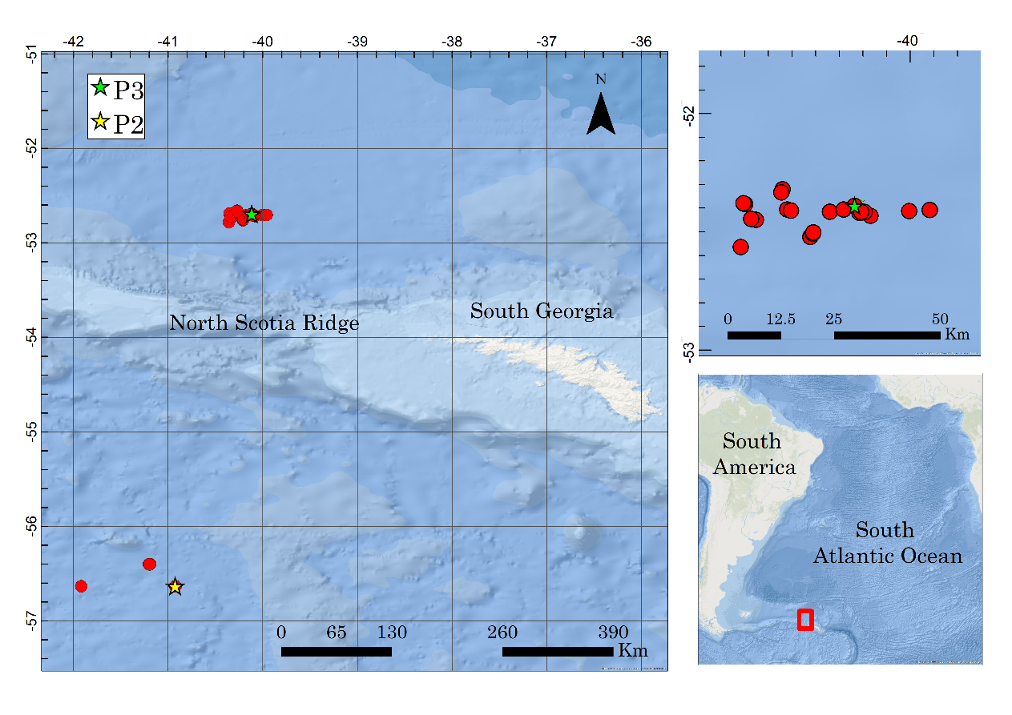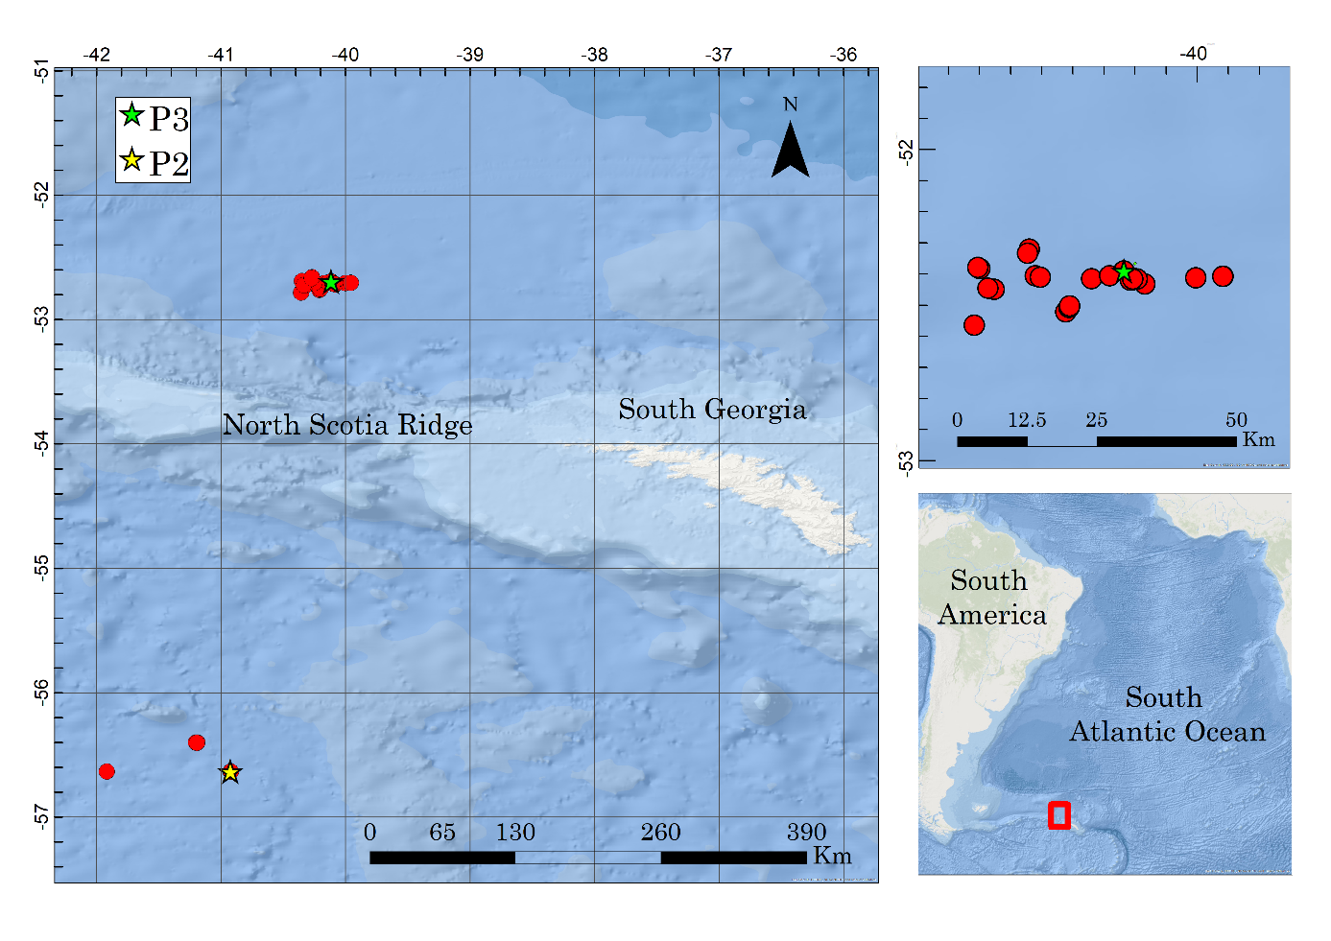

**(a)**

**(b)**

**Figure 2. Locations of South Georgia, site P3 and ship-based deployments. (a)** South Georgia is a small island located in the South Atlantic Ocean to the east of South America. **(b)** Deployments of the CTD and RCF (red) were made during the COMICS cruise DY086 at station P3 (green star) in the Georgia Basin to the northwest of South Georgia. Figure from East (2018, *unpublished*).

### 2.1.2. Red Camera Frame

The RCF carried four optical sensors (LISST HOLO, P-Cam, Eco Triplet and RBR Concerto), which aimed to characterise and quantify the particle field in the epipelagic and upper mesopelagic zones. From this platform, this study used data from the Eco Triplet and RBR Concerto. Due to a 250 m depth limit on the LISST HOLO, each deployment consisted of two profiles: one to 250 m and a subsequent one to 500 m. Speed of descent was about 0.2 m s-1 and ascent was either 0.2 or 1.0 m s-1 depending on time availability. For each RCF deployment, data collected and used in this study consisted of CTD data from the RBR and chlorophyll fluorescence and backscatter from the WET Labs ECO Triplet.

### 2.1.3. WET Labs ECO Triplet, RBR Concerto, and Seabird CTD

A WET Labs Environmental Characterization Optics (ECO) Triplet, measured backscatter at two wavelengths (532 nm and 700 nm) and chlorophyll fluorescence (695 nm). Due to its depth rating, the ECO Triplet was deployed on the RCF and the Seabird CTD rosette on profiles up to 1000 m. As this sensor does not have a pressure sensor, it relies heavily on the time variable for data interpretation. Pressure is recorded by the RBR Concerto or the Seabird CTD for the RCF or CTD rosette deployments, respectively. All instruments were set to ship’s time (GMT) to facilitate merging the dataset later on. For deployments on both the RCF and CTD rosette, the ECO Triplet was positioned horizontally and facing outward. Specific details on deployments of the Seabird 911 CTD Rosette could not be found in the cruise reports, but notes on specific CTD casts can be seen in Table A2 (*Appendix*). The CTD was deployed fewer times with the ECO Triplet than the RCF. Only seven of the total of 27 CTD casts used in this study were equipped with an ECO Triplet.

## 2.2. Data analysis

Variables were constructed into matrices with each column representing one deployment (CTD or RCF). Deployments of the RCF typically consisted of two profiles: one shallow profile to a maximum of 250 m, and a second deeper profile to roughly 450 m. Files originally containing two deployments were separated into two columns and the initial descent and ascent of the platform to ‘warm-up’ the sensors was excluded from data analysis. Two MATLAB files were created: one named ‘ctdmat.mat’ for CTD data that included all usable CTD data from station P3 and a second named ‘combmat.mat’ which contained ECO Triplet data from both the CTD and RCF as well as physical data for those same deployments.

### 2.2.1. Physical variables analyses

Salinity and temperature were binned into 2 m bins and then smoothed with a 7-point running median. Absolute pressure was converted to depth below sea surface (m), using the GSW Oceanographic Toolbox (McDougall and Barker, 2011). Salinity and temperature cross-sections (time versus depth) were plotted in MATLAB to characterise water column dynamics over time. A temperature salinity diagram was plotted to identify and characterise the different water masses present. Depth of maximum buoyancy frequency (N2) was calculated and plotted as a horizontal line for each deployment over profiles of temperature and salinity versus depth to determine whether the depth of maximum N2 was a reasonable predictor of the mixed layer depth (Carvalho *et al.,* 2017). Mean temperature and salinity profiles were calculated for each visit to the station (P3A, P3B, and P3C).

### 2.2.2. Optical calibrations

Factory supplied parameters were used to convert raw digital counts from the ECO Triplet into chlorophyll fluorescence and backscatter (700 nm) concentrations (Table I; 532 nm was not used in this study). The decision to focus on the backscatter at 700 nm was based on the fact that this wavelength has been used more frequently and provided better terms for comparison (Briggs *et al.*, 2011a; Estapa *et al.*, 2013; Dall’Olmo and Mork, 2014). Factory dark values were subtracted from ECO Triplet raw digital counts and were then converted to the volume scattering functions using scale factors from factory supplied calibrations (Eq. 1 and 2).

**(1)** CHL (μg/l)= Scale Factor x (Output-Dark counts)

**(2)** β(θc) m-1sr-1 = Scale Factor x (Output-Dark counts)

**Table I.** **Factory supplied parameters.** The following values were used to convert raw data into chlorophyll fluorescence and volume scattering functions.

|  |  |  |
| --- | --- | --- |
|  | ECO Chlorophyll Fluorometer | Scattering meter  at 700 nm |
| Scale Factor (SF) | 0.0305 μg l-1 counts-1 | 3.004E-06  m-1 sr-1 counts -1 |
|  |  |  |
| Dark Counts | 53 counts | 52 counts |

The volume scattering function of seawater was calculated following Zhang *et al.* (2009). The resulting value was then subtracted from the volume scattering functions to find the scattering due to particles βp(θ,λ) which was converted to integrated particulate backscattering, *bbp(λ)*, according to Eq. 3 (Briggs *et al.,* 2011a):

**(3)** *bbp(λ)=2πχ*βp(θ,λ)

where χ = 1.077 (factor to convert on angle bbp to all angles from WET Labs).

Chlorophyll a concentrations from the CTD rosette were corrected using chlorophyll bottle data collected on the same CTD (R2=0.69; y= 1.4905x + 0.246). The corrected CTD chlorophyll concentrations were used to calibrate the ECO Triplet chlorophyll concentrations for casts on the CTD rosette. First, CTD chlorophyll concentrations were plotted against co-located ECO Triplet chlorophyll concentrations and a Model II linear regression was run (R2= 0.97; y= 0.8805x + 0.3479; Figure 3a). This equation was then used to calibrate chlorophyll concentration values from all ECO Triplet deployments (on the CTD and RCF). Lastly, the calibrated data from the ECO Triplet (RCF) was used to calibrate co-located chlorophyll concentration values recorded by the RBR on the RCF using another Model II Linear Regression (R2=0.96; y= 0.3327x + 0.177; Figure 3b). An example of chl values from one cast before and after calibration can be seen in Figure 3c.

### 2.2.3. Optical baseline analyses

Spikes and baselines of chl and backscattering were separated. Using the function ‘separate_spikes_median.m’ by Nathan Briggs (2011b), a running median filter separated a baseline optical signal from rarer optical spikes. A window size of 15 was used. Baseline values of bbp700 and chlorophyll a were binned into 10 m and 0.5-day bins to reduce sub-mesoscale temporal variability, and smoothed using a 50 m running mean. Data were not smoothed by time because time-gaps in the data meant they were not continuous, and thus time-smoothing would produce identical data points during multiple observation time periods.

Because POC samples collected for this cruise were not processed before this study was completed, a backscattering-to-POC ratio of 37000 mg C m−2 taken from the literature (Cetinić *et al.,* 2012; rounded value for surface ocean), was used to convert bbp700 to POC concentration in the surface ocean. Binned spike data were plotted from 100-800 m to observe evidence of aggregate flux below the mixed layer. Maximum spike signals below 200 m, and their corresponding depths, were calculated and a regression was originally planned to be performed on this data, although the data did not allow for this (see section *Results* for further information).

**Figure 3. Chlorophyll a calibration.** Two Model II regressions were run to calibrate chlorophyll optical data to chlorophyll bottle data (collected on the CTD). **(a)** Corrected CTD chlorophyll data was calibrated with collocated ECO Triplet data. **(b)** This same equation was used to calibrate the ECO Triplet profiles from the RCF and collocated RBR chl data was calibrated. **(c)** An example of before and after calibrating chl values. Raw chl (orange; ‘before’), calibrated chl a (black; ‘after’), and the ECO Triplet data used to calibrate (blue) on one RCF cast.

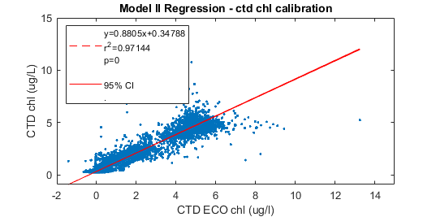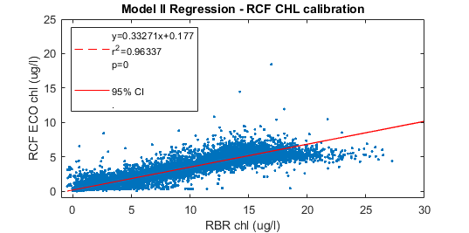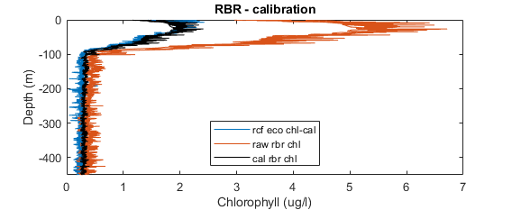

**(c)**

**(b)**

**(a)**

### 2.2.4. Optical spike analysis

Preliminary analysis of spikes consisted of binning mean spike magnitudes into 10 m and 0.5 day bins to look at flux of larger particles out of the surface layer. After smoothing data using a 50 m running median window, the plan was originally to calculate aggregate flux below the surface layer by isolating backscatter and fluorescence spikes according to Briggs *et al.* (2011a). For example, a type I linear regression of time of maximum spike signal versus depth was to be utilised to estimate particle sinking rate. However, large data-gaps in time, especially between visit P3A and P3B prevented this, as the analysis requires a dataset that is continuous in time. The follow up method focused on using spike frequency rather than spike magnitude. After preliminary plotting and analysis, it was also determined that there wasn’t enough chlorophyll spikes for analysis, so all subsequent analyses were completed on bbp700 spike values alone.

A maximum noise threshold was determined for each platform by calculating the median spike value and multiplying by two (CTD noise threshold = 1.2197 x 10-4 m-1; RCF threshold= 2.0327 x 10-4 m-1; resulting in the noise threshold of the RCF being 2/3 larger than CTD threshold). These platform-specific thresholds were subtracted from all spike values from each platform to account for instrument noise and produce conservative spike values. Two additional spike matrices for CTD and RCF spikes were created using the mean of the CTD and RCF thresholds (mean threshold= 1.6262 x 10-4) to test the effect of the magnitude of noise threshold on this study’s results. The resulting spike data were then organized into four matrices which are subsequently be referred to as CTD specific threshold, RCF specific threshold, CTD equal threshold, and RCF equal threshold. These matrices were used to compare how platform type, and noise threshold values (different thresholds per platform versus equal thresholds) affected the backscatter spike analyses.

Because deployment speeds were different for RCF and CTD rosette deployments and speed of the sensor (which samples at one hertz) can affect optical spike data, bbp700 spikes for each platform were considered separately. First, spike data in backscattering units (m-1) were separated into downcasts and upcasts. Due to upcasts speeds being generally faster and more variable for multiple reasons, including bottle deployments on the CTD and time limitations, only downcasts were used in this analysis. Furthermore, evidence suggests that platforms travelling through the water column can breakup larger particles and aggregates, thereby significantly changing optical data on the upcast relative to downcast (Briggs *et al.,* 2011a). Optical data profiles can exhibit higher baseline values and fewer (or of lesser magnitude) spike values on the upcast relative to the downcast.

Next, average cast speed was calculated for each downcast by dividing maximum depth by time interval of the downcast. Casts with speeds more than two standard deviations away from the mean were discarded. Then, depth versus time were plotted to visually inspect if the platform had travelled at a relatively constant speed with depth. If they did not, they were also excluded from analysis. Final downcast mean velocities were 0.66 m s-1 for the CTD and 0.16 m s-1 for the RCF. On average, the CTD travelled about four times as fast as the RCF.

### 2.2.5. Spike frequency attenuation

Spike frequencies were calculated for four separate backscattering spike matrices: one CTD spike matrix using a CTD-specific noise threshold, one RCF spike matrix using an RCF-specific noise threshold, one CTD matrix using the mean threshold (equal threshold; mean of CTD and RCF noise threshold), and one RCF matrix also using the mean threshold. Subsequently, spike frequency was calculated in 75 m depth bins for every matrix by dividing the number of spikes observed by total number of observations made in each depth bin. This accounts for differences in number of casts per depth bin and represents concentration of large particles or aggregates at specific depths.

Spike frequency at different depth bins was plotted against depth and a curve was fit to the data similar to that of the Martin curve (Martin *et al.,* 1987; Eq. 4):

**(4)** *f(x) = a*(x/112.5)-b*

where *f(x)* is spike frequency at depth *x, a* is the calculated spike frequency at depth 112.5 m, *x* is depth (m) and *b* is the attenuation coefficient. Curve fitting was forced through the second bin value (112.5 m), a depth that lies below the surface layer containing highest chlorophyll a and POC concentrations. The shallowest depth bin (37.5 m) was excluded from the curve fitting because the link between optical spikes and particles in the mixed layer is not as clear as their relationship under the mixed layer (Briggs *et al.*, 2011a). In addition, a running median filter can underestimate the height of optical spikes when optical spike frequency is very high (i.e. in the surface layer when a phytoplankton bloom is occurring, such as observed during this study). To look at temporal evolution of particle attenuation at P3, curves were fit to binned spike frequencies by visit (P3A, P3B and P3C). CTD data was not included in this analysis as there were not enough data for a statistically significant fitting. For the RCF we present results from the two different threshold methods (specific and mean threshold). Following, spike frequencies were analysed within the same depth bins for both the RCF and CTD, but for the entire duration of the cruise (no time binning). Attenuation curves of spike frequency with 95% confidence intervals were also calculated.

### 2.2.6. Estimating POC flux

Flux of POC was estimated at 200 m (Flux200) by using Equation 5 below:

**(5)**  *Flux200= mean spike height* ***x*** *spike frequency200* ***x*** *POC-bbp700-ratio* ***x*** *sinking rate,*

where *mean spike height* is the average spike magnitude across the entire matrix in units m-1, *spike frequency200* is depth corrected spike frequency at depth 200 m from Eq. 4, *POC-bbp700-ratio* is the backscattering to POC ratio in mg C m−2, and *sinking rate* is equal to the mean gravitational sinking rate of particles through the water column.

POC values and sinking rates from the DY086 cruise have not been analysed and estimated yet, meaning that the in situ backscattering-POC ratio and particle sinking rates were not available from the cruise calibration casts. Instead, a backscattering-POC ratio and sinking rate used in these analyses were taken from the literature: 31000 mg C m−2 (Cetinić *et al.,* 2012; rounded value for below the mixed layer) and 100 m d-1 (Cavan *et al.,* 2015), respectively. While Cavan *et al*. (2015) found a wide range of sinking rate of POC in the Scotia Sea (50-430 m d-1), a value from the lower end of this range was selected. Personal communication regarding particle observations on cruise DY086 suggested few large aggregates were present. Korb *et al*. (2012) reported early summer blooms in this region to be dominated by heavily silicified diatoms, such as *Chaetoceros pennatum*. Thus, particles likely sinking through the water column during this time period such as diatom chains and faecal pellets, although small, will not be at the absolute lowest end of this range. Again, at this time no taxonomic data is available yet for this cruise.

Flux200 (Equation 5) was evaluated four times for the four spike matrices and 95% confidence intervals of POC flux were calculated using the confidence intervals of the b-values. These values were then compared with values from the literature. The four POC fluxes were compared to evaluate the effect of differences in noise thresholds and methodologies on optical spike data.

# 3. Results

## 3.1. Oceanographic setting

Depth of maximum buoyancy frequency was initially calculated in order to determine mixed layer depth. However, this value varied so greatly between any two profiles, that it was deemed not an accurate estimate of the mixed layer depth, especially during earliest dates (Figure 4). As time for analyses was constrained, a depth of 50 m was selected to look at different variables in the surface ocean and will hereafter be referred to as the *surface layer*. In the future, the mixed layer depth should be quantified using another method such as density criterion (0.05 kg m-3).

Temperature values in the surface layer increased gradually from the beginning of observations during P3A (mid-November) until the end of observations during P3C (mid-December; Figure 5). Temperature averages in the surface layer varied from 2.30 °C to 3.61 °C with the minimum temperature occurring on November 16th (P3A) and maximum occurring on the last day data was collected (December 15th). This corresponds to an increase in mean surface layer temperature of 1.31 °C in one month. Deeper than 100 m, less variability was observed in temperature. Average minimum water column temperature was observed to be 0.80 °C. Minimum temperature occurred at an average depth of 143 m. This cold and fresh water mass can be seen on the temperature salinity diagram as well as the temperature depth-time scatter plot (Figure 5)and has been identified as the Winter Water (WW) water mass. WW, a characteristic water of the Southern Ocean, is the remnant surface water from the winter season. Mean temperatures in the surface layer during P3A, P3B and P3C were 2.38, 3.14 and 3.39 °C respectively (Figure 6a). Thermal stratification in the surface ocean can be observed developing in the mean profile of P3C, which exhibits a step-like shape in the upper 70 m.

Salinity values showed low variability during observations made at P3 (Figure 5a and 6b). Mean salinity in the surface layer exhibited relatively little variation (± 0.07 psu). Salinity was lowest at the surface (mean in the upper 50 m= 33.82 psu) and gradually increased with depth. Mean salinity in the upper 50 m during P3A, P3B and P3C barely increased over time (0.01 psu; Figure 6b).

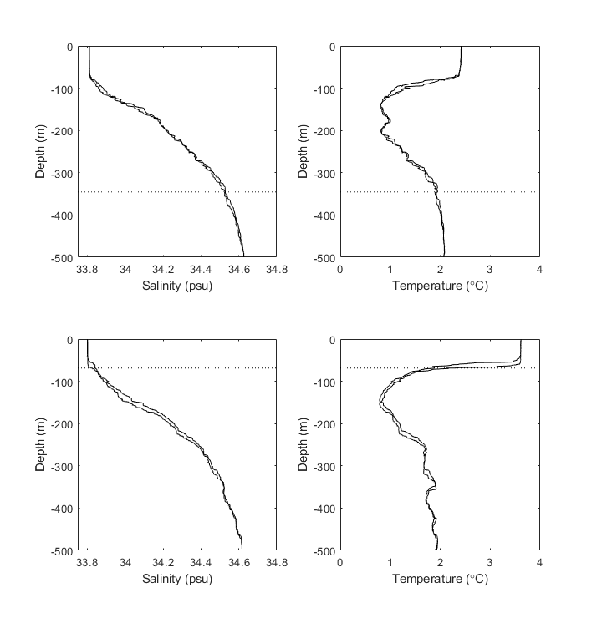**Figure 4. Example of depth of maximum buoyancy frequency (dotted black line) compared with smoothed salinity and temperature profiles (solid black line).** Depth of maximum buoyancy frequency was calculated to determine mixed layer depth, but deemed not a good estimate after comparing with salinity and temperature profiles. **(a) CTD profile during P3A.** Earlier in the cruise, the water column is not as stable compared to later dates, and depth of maximum buoyancy frequency is > 300 m, which is unlikely to be representative of the ecologically significant mixed layer depth. **(b) CTD profile during P3C.** As temperature increases in the surface layer over time, depths of maximum buoyancy frequency generally decreased to a shallower depth which sometimes corresponds well with well-mixed layers in salinity and temperature profiles.

**(a)**

**(b)**

**(a)**

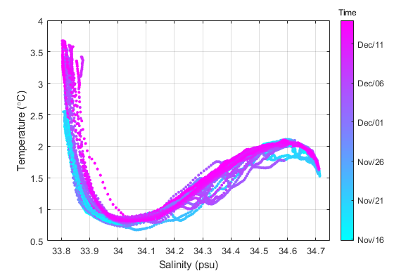**Figure 5. Oceanographic setting at P3 from November-December 2017.** Over time, temperature increased in the surface layer (upper 50 m) while interior temperature and salinity stayed relatively constant. **(a)** A T-S diagram shows warming in the surface layer, and a cold and fresh Winter Water (WW) layer sitting beneath. **(b)** Temperature scattered over time (x-axis) and depth (y-axis). Here, a general warming pattern including thermal stratification in the surface layer is visible, with a cold WW layer located beneath (approximately 150 m). Coloured boxes show time periods associated with visits P3A, P3B and P3C.

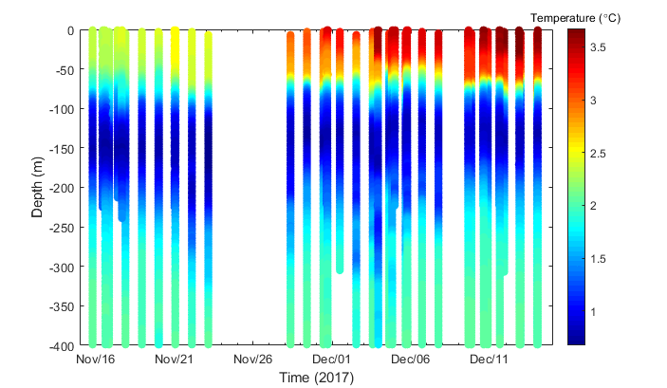

**P3A**

**P3B**

**P3C**

**(b)**

**(b)**

**(a)**

## 3.2. Temporal evolution of chlorophyll a concentration

Concentration of chlorophyll a (chl) from processed optical baseline (without spikes) data decreased in the surface layer over the time period observations were made (Figure 7a). The maximum value found in smoothed chlorophyll data was 5.52 mg m-3 which occurred at depth bin 30 m on November 17th. Mean chl in the upper 50 m was highest during P3A with a maximum concentration of 5.30 mg m-3 occurring on November 17th. Mean concentration in the surface layer reached a minimum of 1.37 mg m-3 on December 10th during P3C.

Average values between 150 and 200 m were calculated because an increase in chl was visible during P3B and P3C (Figure 6d; Figure 7a). The highest average chlorophyll a concentration occurring at this depth range was equal to 0.28 mg m-3 (matching the bottom of the Winter Water) on November 29th during P3B. Minimum concentration at the same depth range (150-200 m) was equal to 0.01 mg m‑3 on November 16th during P3A, one day before maximum mean chl in the surface layer.

Mean chl in the upper 50 m for P3A, P3B and P3C decreased over time (Figure 6d). P3A had a mean chl concentration of 4.79 mg m-3. About a week later during P3B, mean concentrations had decreased to 2.46 mg m-3 which decreased further to a value of 1.88 mg m-3 during P3C. While the concentration of chl in the surface layer is almost constant during P3A, concentrations decrease in the shallowest depths compared to 50 m during P3B and P3C (Figure 6d). Mean chl below the surface layer (125-175 m) in mean profiles increased from P3A to P3B, and then decreased during P3C (Figure 6d). Mean chl for this depth range was 0.07, 0.16 and 0.11 mg m-3 for P3A, P3B, and P3C, respectively.

## 3.3. Temporal evolution of particulate organic carbon concentration

Less profiles for backscattering were used compared to fluorescence profiles as there were multiple sensors measuring chlorophyll fluorescence (fluorometer on CTD rosette, RBR concerto and ECO Triplet) and all profiles collected are shown including the ones without the ECO triplet present (the only sensor measuring backscatter). This is what causes the observed difference in temporal coverage of data displayed in Figure 7a and 7b. Concentration of POC followed similar patterns to chlorophyll a concentration: a decrease was observed in the surface layer with time and an increase in concentration was visible during P3B and P3C compared to P3A under the surface layer (Figure 6c and Figure 7b). Mean POC concentration in the surface layer was highest during P3A with a maximum concentration of 240.78 mg m-3. A minimum of POC concentration in the upper 50 m was observed on the last day of observation (P3C) and was equal to 90.67 mg m-3 (38% decrease).

A signal of increased concentration occurring at the bottom of the Winter Water could be seen in POC concentration (similar to chlorophyll concentration in section 3.2; Figure 7a and 7b). At a depth interval of 150 to 200 m, a maximum mean POC concentration was observed as 32.75 mg m-3 during P3B. Minimum concentration at the same depth range (150-200 m) was equal to 15.00 mg m-3 during P3C.

Mean POC concentrations per visit in the surface layer decreased over time (Figure 6c). The patterns observed in mean POC profiles for each visit are similar to patterns in chlorophyll a concentrations described in section 3.2. During P3A, POC concentrations reached maximum values equal to 223.10 mg m-3. By visit P3B, the mean POC concentration had decreased to 130.69 mg m-3, and decreased further to a value of 105.28 mg m-3 by P3C. Mean POC concentration below the surface layer (125-175 m) in mean profiles increases from P3A to P3B, and then decreases at P3C (Figure 5c). Mean POC concentrations for this depth range were 22.01, 26.74 and 18.30 mg m-3 for P3A, P3B, and P3C respectively.

**Figure 6. Summary diagram of the temporal evolution of salinity, temperature, POC concentration and chlorophyll a concentration in the upper 250 m at P3.** P3A (earliest visit) is denoted with light blue, P3B with dark blue, and P3C (latest visit) in magenta. **(a)** Mean temperature profiles become warmer in the surface layer over time, developing a step-like profile by P3C. Winter Water (cold mass around 150 m) slightly shallows with time. **(b)** Mean salinity profiles increase slightly at approximately 150 m with time but stay relatively constant at the surface. **(c)** POC concentration decreases in the surface layer, with increased concentration at approximately 150 m visible during P3B. **(d)** Chl concentration decreases in the surface layer over time with slightly increased concentrations below the surface layer at P3B and P3C compared to P3A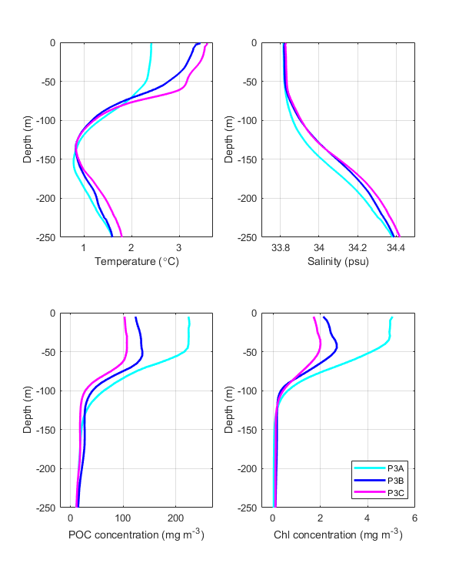.

**(a)**

**(b)**

**(c)**

**(d)**

**Figure 7. Temporal evolution of chlorophyll a and POC concentration in the upper 800 m at P3.** Both chl and POC are plotted in log space with time on the x-axis and depth on the y-axis. Coloured boxes at the middle of the figure indicate time periods that each visit occurred (P3A= cyan; P3B= dark blue; P3C= magenta). **(a)** Chlorophyll a concentration decreased in the surface layer during the time period of the cruise, with a signal of a flux event occurring at the end of November visible at approximately 150 m (P3B). Concentrations under the surface layer remain elevated for the duration of the cruise. **(b)** Patterns in POC concentration are similar to those in chlorophyll. POC concentrations decrease in the surface layer over time, with elevated concentrations seen under the surface layer starting the end of November (P3B).

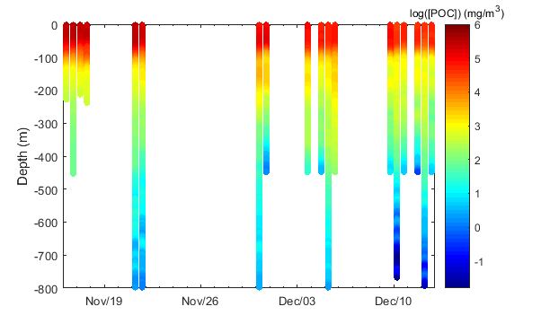

**(b)**

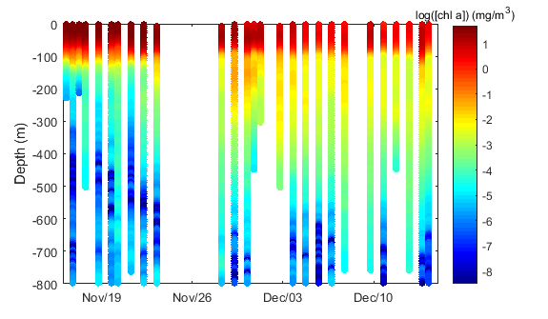

**P3A**

**P3B**

**P3C**

**(a)**

**(a)**

## 3.4. Analysis of backscatter spikes

Initially, optical spike data for both chlorophyll and backscattering were plotted in a scatter diagram using 10-m and 0.5-day bins, then smoothed by depth to look at evolution of larger particle concentration in the water column over time. However, so few chlorophyll spikes were present that the desired analysis could not be performed. Thereafter spike processing was focused solely on backscattering (700 nm). Although elevated spike values can be seen under 100 m during P3B which could be indicative of a flux event, missing data before this event and the temporal resolution of the entire data set posed a problem in data analysis. Thus, mean sinking rate was not calculated using maximum spike signal depth (see section Methods); instead analysis used spike frequency to look at particle patterns in the water column.

### 3.4.1 Temporal evolution of spike frequency attenuation

Spike frequency attenuation, indicative of large particle attenuation in the water column, was first calculated for P3A, P3B, and P3C using RCF downcasts because downcasts were deployed at more uniform speeds (Table II; Figure 8). Here, attenuation of spike frequencies from RCF-specific threshold and RCF equal threshold spikes are considered separately. After fitting Eq. 4 to binned spike frequency values, b-values for RCF-specific spikes ranged from a minimum of 0.87 at P3C (R2 =0.98) to a maximum of 1.34 at P3A (R2 =0.99; Table II). Confidence intervals of 95% of the b-values from each time period overlapped, indicating that the attenuation coefficient does not significantly vary with time.

For the RCF equal threshold spike frequencies, b-values were found to range from 0.71 at P3B (R2= 0.97) to a maximum b-value of 1.27 at P3A (R2=0.96). An intermediate b-value occurred at P3C (b=0.87; R2= 0.99). Contrasting the b-values from the RCF equal threshold spike frequencies, not all the b-value’s confidence intervals overlap. While b-values from both P3A and P3B overlap with P3C, b-values for the first two visits do not overlap with each other (95% C.I. P3A= 0.93-1.6; 95% C.I. P3B= 0.60-0.82).

### 3.4.2. Attenuation of spike frequencies across platforms and noise thresholds

Spike frequency attenuation for the entire time at P3 were compared for both platforms (Table II; Figure 9). First, RCF and CTD spikes derived from platform-specific noise thresholds will be discussed, followed by the analysis using an equal noise threshold. Fitting RCF spike frequencies (RCF-specific threshold) to Eq. 4 yielded a b-value of 1.01 (R2=0.94, 95% C.I.= 0.87-1.15). Fitting the same equation to CTD spike frequencies (CTD-specific threshold) yielded a b-value of 0.64 (R2=0.78; 95% C.I.= 0.52-0.76). Spike frequency attenuation calculated from the RCF and CTD using platform-specific noise thresholds are significantly different from one another (Figure 9a).

Conversely, calculating b-values for CTD and RCF spikes using the same noise threshold yields b-values that have overlapping confidence intervals (Figure 9b). Fitting Eq. 4 to the equal-threshold matrices produced a b-value of 0.90 from the RCF (R2=0.99; 95% C.I.= 0.79-1.015) and 0.78 from the CTD (R2=0.83; 95% C.I.= 0.64-0.92). Hence, spike frequency attenuation calculated using different platforms travelling at different speeds but the same noise threshold yielded attenuation coefficients that were statistically equivalent.

**Table II. Spike frequency attenuation curve model outputs. Attenuation coefficients calculated from spike frequencies collected by different platform types and derived using different noise thresholds are presented below. Last column ‘b-value C.I. overlap’ states whether attenuation coefficients within same analyses are statistically equivalent or not. The ‘a-value’ is the calculated spike frequency at the 112.5 m bin in which the curve is forced through.**

|  |  |  |  |  |  |  |  |
| --- | --- | --- | --- | --- | --- | --- | --- |
| **Platform** | **Noise threshold** | **Visit** | **b-value** | **95% C.I. (b-value)** | **R2** | **a-value** | **b-value C.I. overlap?** |
| RCF | RCF-specific | P3A | 1.3440 | (0.923, 1.7650) | 0. 9427 | 0.1836 | Yes (all visits) |
|  |  | P3B | 0.8668 | (0.7322, 1.001) | 0. 9778 | 0.1796 | Yes (all visits) |
|  |  | P3C | 0.9197 | (0.8387, 1.001) | 0. 9939 | 0.1417 | Yes (all visits) |
| RCF | equal | P3A | 1.2670 | (0.9270, 1.6080) | 0.9546 | 0.2125 | Yes (only P3C, not P3B) |
|  |  | P3B | 0.7126 | (0.6006, 0.8246) | 0.9733 | 0.2029 | Yes (only P3C, not P3A) |
|  |  | P3C | 0.8677 | (0.7679, 0.9676) | 0.9893 | 0.1748 | Yes (all visits) |
| RCF | RCF-specific | P3 (all) | 1.0110 | (0.8714, 1.1510) | 0.9382 | 0.1695 | No (CTD-specific (P3)) |
| CTD | CTD-specific | P3 (all) | 0.6406 | (0.5176, 0.7637) | 0. 7788 | 0.1777 | No ( RCF-specific (P3)) |
| RCF | equal | P3 (all) | 0.9026 | (0.7905, 1.015) | 0.9864 | 0.1973 | Yes (CTD-equal (P3)) |
| CTD | equal | P3 (all) | 0.7829 | (0.6445, 0.9212) | 0.8309 | 0.1491 | Yes (RCF-equal (P3)) |

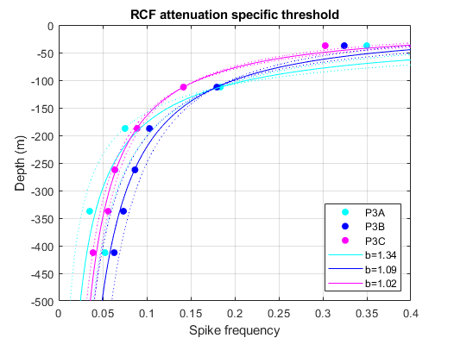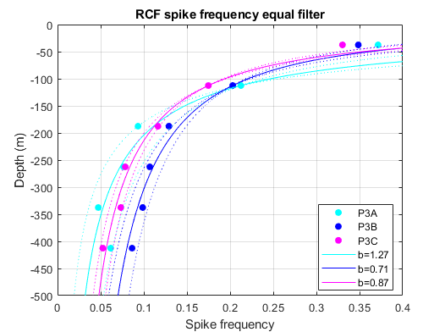

**(a)**

**(b)**

**Figure 8. Temporal evolution of spike frequency attenuation per visit to station P3 using platform-specific and equal noise thresholds.** Only casts from the RCF were used in this analysis. **(a) RCF-specific noise threshold**. Although a general decrease in b-value magnitude is observed with time, 95% C.I.s overlap meaning attenuation is not significantly different through time. **(b) Equal noise threshold (equal to CTD).** Overall, b-values at every visit decreased compared to b-values calculated using an RCF-specific noise threshold. The b-value at P3A is significantly different from the b-value at P3B, but both are statistically the same to the b-value calculated for P3C. Similarly, the attenuation curves of P3A and P3C do not overlap between roughly 200-500 m.

**Figure 9. Comparison of spike frequency attenuation derived from different platforms and noise thresholds.** Data combined across all visits to P3. **(a) Spike frequency attenuation derived from platform-specific noise thresholds.** Here, the b-value from the RCF is significantly higher than the b-value from the CTD. Binned spike frequencies from the RCF are overall slightly lower than those from the CTD for the same depth bin. **(b) Spike frequency attenuation derived from equal noise thresholds.** Although the b-value from the RCF was slightly higher, b-values from the RCF and the CTD were not significantly different (95% C.I.s do not overlap). Spike frequencies from the RCF are higher than the CTD at every depth bin in which the RCF collected data.

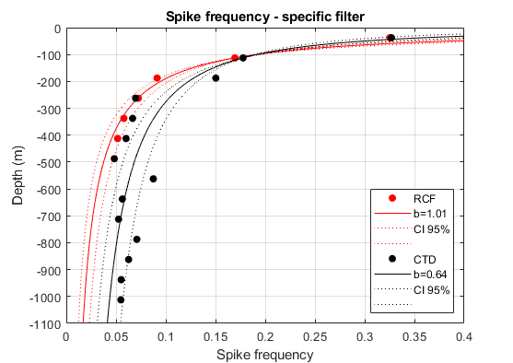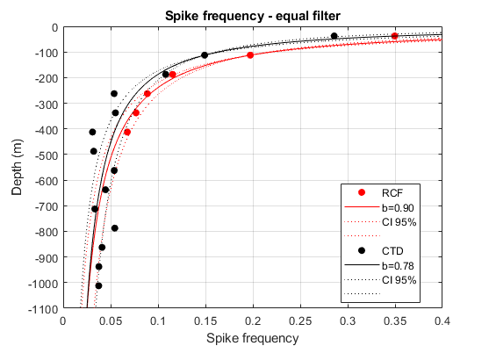

**(a)**

**(b)**

## 3.5. Estimated POC flux

POC flux at 200 m (Equation 5) was evaluated four separate times to compare POC flux estimates across different platforms and noise thresholds. POC flux was estimated at 200 and 2000 m using depth corrected values of spike frequency from the results in section 3.4.2. Although POC flux estimates from the same platform overlapped (comparing platform-specific values versus equal threshold values), flux estimates between the two platforms (RCF versus CTD) differed for both specific-threshold and equal-threshold derived values at 200 m (Table III). Estimated POC flux at 200 m was 239 mg m-2 d-1 (95% C.I. = 220-259 mg m-2 d-1) from the RCF and 172 mg m-2 d-1 (95% C.I. = 160-184 mg m-2 d-1) from the CTD, using platform-specific noise thresholds.

Using spike frequencies calculated with equal noise thresholds, POC flux estimates showed opposite trends with RCF flux increasing and CTD flux decreasing, although these values are not significantly different from those described above (Figure 10). For the CTD, POC flux estimate decreased to 156 mg m-2 d-1 (95% C.I. =144-168 mg m-2 d-1). Conversely, the RCF flux estimate increased to 265 mg m-2 d-1 (C.I. 95%= 249-283 mg m-2 d-1). At 200 m, the POC flux estimates have a relatively large range of 144-283 mg m-2 d-1.

The range of POC flux estimates diminishes with depth. For example, at 2000 m, POC flux estimates across all platforms and noise thresholds overlap and the entire range of POC flux is from 16-56 mg m-2 d-1, a range 71% smaller than the range of POC flux at 200 m (Table III). POC fluxes from platform-specific noise thresholds converge to a single value at a particular depth before starting to diverge again (Figure 10a). POC flux estimates from the CTD and RCF converge at 488 m depth to a value of 97 mg m-2 d-1. Equal threshold derived POC fluxes do not converge between 0-2000 m (Figure 10b).

When comparing 95% confidence intervals of POC fluxes between platforms, these intervals do not overlap in the surface layer but do converge with depth. Confidence intervals continued to overlap to the maximum depth considered in this study (2000 m; Figure 10a and 10b). Comparing POC fluxes calculated using platform-specific noise thresholds, confidence intervals began to overlap at a depth of 265.5 m. POC fluxes calculated using an equal-threshold converge at a deeper depth to the one mentioned above: 572 m.

**Table III. POC flux estimates at 200 and 2000 m using different platforms and noise thresholds.** Platform type was either RCF or CTD, and noise thresholds were either platform-specific or equal. The effect that platform has on estimated POC flux is much more evident at 200 m than 2000 m with RCF consistently predicting a higher POC flux at 200 m. Conversely, at 2000 m the RCF equal threshold and CTD-specific threshold lead to the highest POC flux estimates. At 2000 m, all POC flux estimates are statistically equivalent.

|  |  |  |  |
| --- | --- | --- | --- |
| Platform | Noise threshold | POC flux at 200 m | 95% C.I. |
| RCF | RCF-specific | 239 | 220-259 |
| RCF | equal | 265 | 249-283 |
| CTD | CTD-specific | 172 | 160-184 |
| CTD | equal | 156 | 144-168 |

|  |  |  |  |
| --- | --- | --- | --- |
| Platform | Noise threshold | POC flux at 2000 m | 95% C.I. |
| RCF | RCF-specific | 23 | 16-35 |
| RCF | equal | 33 | 24-46 |
| CTD | CTD-specific | 39 | 28-56 |
| CTD | equal | 26 | 17-38 |

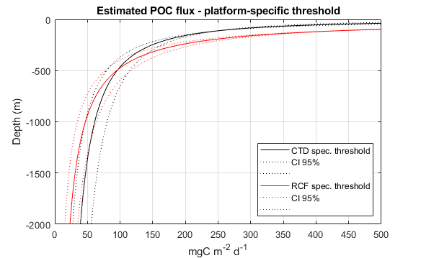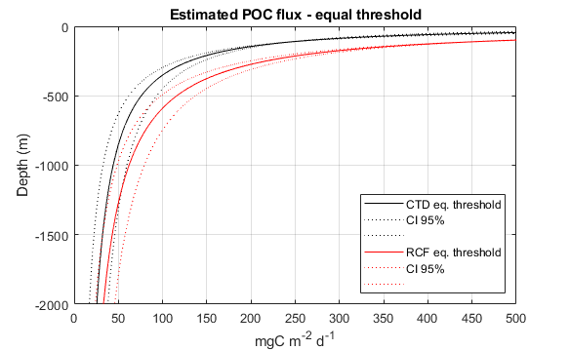

**(a)**

**(b)**

**Figure 10. Estimated POC fluxes derived using different platforms and noise thresholds.** POC estimates were calculated using Eq. 5 (section 2.2.6). **(a) RCF (red) and CTD (black) derived POC fluxes using platform-specific noise thresholds.** While significantly different at 200 m, confidence intervals overlapped at 265.5 m. RCF- derived POC flux is slightly lower than CTD-derived at depth and higher in the surface. **(b) RCF and CTD derived POC flux using an equal noise threshold.** POC fluxes began overlapping at 572 m. RCF-derived values at 2000 m are higher and CTD-derived values lower than those in Figure 10a, although the difference is not significant.

# 4. Discussion

## 4.1. Oceanographic setting: comparison with the literature

As shown in section 3.1, temperature varied during the time period of the study. Temperature increased in the surface layer, and step-like thermal stratification in the upper 50 m formed by the last visit to the station (P3C; Figure 6a). The observed temperature increase during November and December in South Georgia is likely seasonal rather than mesoscale variability because it is sustained warming in the surface layer that persists during the entire duration that observations were made (one month).

During the last day of the cruise (P3C; December 15th) the upper 50 m exhibited a relatively high average temperature of 3.61 °C. In comparison, temperature in the upper mixed layer (27±4 m) was observed to reach a maximum of 4.17 °C to the northwest of South Georgia from 9 January–16 February 2003 (Korb *et al.,* 2005). The maximum mean temperature recorded at shallower depths (and likely biasing the value to be even warmer) is only 0.56 °C warmer than the values found in this study. This is surprising considering February and March are documented as the months when temperatures typically reach maximum values near South Georgia (Whitehouse *et al.*, 2008). In recent decades, even greater seawater temperatures of >5 °C have been recorded in the Georgia Basin (Korb *et al.,* 2005). However, in 1930, the average temperature for the same depths in January and February 1930 were recorded as being around roughly 3.6 to 3.75 °C (Deacon, 1977; as seen in Whitehouse *et al.,* 2008). Taking into account these temperature values recorded during ‘warmer’ months by Deacon *et al.* (1977) and Korb *et al.* (2005), a value of 3.61 °C already being reached by mid-December is uncharacteristically warm.

Although interannual temperature variability has been reported in the Scotia Sea, evidence of a strong long-term warming trend was found in this region (Whitehouse *et al.,* 2008). The study compiled almost year-round temperature data from South Georgia over an 81-year period (1925–2006) and found a strong warming trend evident around the island over this time period, with winter months warming significantly faster than summer months. This work defined their study area as the waters around the island of South Georgia between latitude 52°S and 57°S and between longitude 32°W and 42°W, which is a larger area than the once observed in this study. Nevertheless, P3 sits inside their study area, so the warming trend must be observed there as well. Their datasets indicated a significant warming in the top 100 m that exceeds the strong warming of the near-surface Southern Ocean found by Gille (2008).

## 4.2. Bloom dynamics and carbon export in South Georgia

A maximum mean value of chlorophyll a concentration in the upper 50 m occurred November 17th with a value of 5.30 mg m-3. To the northwest of South Georgia, various studies have found higher chlorophyll a concentrations during a bloom compared to the values stated above (Whitehouse *et al.,* 2000; Korb *et al.,* 2005; Cavan *et al.,* 2015). In fact, chlorophyll a concentrations may reach as high as 20 mg m−3 in the waters around South Georgia (Whitehouse *et al.,* 2000). Previous studies have shown that during January and February in this region, surface chlorophyll reached 17 mg m-3 (Cavan *et al.*, 2015; Korb *et al.,* 2005), with an average value of about 3.4 mg m-3.

Typically, phytoplankton growing season ranges between three to six months in productive waters around South Georgia. Regular seasonal blooms have been shown to occur in the Georgia basin (Borrione and Schlitzer, 2013). Paired with increased light availability from the austral spring and summer, this is likely a result of a reliable supply of iron to surface waters from the close proximity to South Georgia Island, similar to other subantarctic islands of the Southern Ocean such as Kerguelen and Crozet. Using a 12-year time series of ocean colour imagery to examine the spatial and temporal bloom distributions around South Georgia from 1997 to 2010, studies have found that regular seasonal blooms occur to the northwest of the island with peaks in chlorophyll a concentration between mid-November and the end of December (Borrione and Schlitzer, 2013). In this study, the ship arrived in mid-November to find bloom-like conditions already present in this region and then observed declining surface concentrations. It is difficult to conclude that the highest values reported here were the peak of the bloom, or if the peak occurred before the ship reached station P3. Austral spring peaks have been observed earlier in the season, as early as October (Borrione and Schlitzer, 2013). These first seasonal peaks usual terminate by the beginning of January, likely due to silicate limitation. During some years, the spring bloom is followed by a second peak or even third peak from January to April. This bi-modal bloom pattern has been attributed to a renewed supply of silicate into the mixed layer (Borrione and Schlitzer, 2013).

No evidence of deep chlorophyll maximums were found in any of the profiles. This finding is corroborated by other studies in South Georgia which found that peak biomass occurred within the upper 20–30 m of the water column (Korb *et al.,* 2005). Highest POC values were seen at very shallow depths (5-15 m) compared to chlorophyll a values being observed deeper (30 m) in this study. POC and chlorophyll a signals can be decoupled at the surface because of non-photochemical quenching, especially when combined with signals of thermal stratification, suggesting the bloom may be dominated by relatively low light acclimated phytoplankton species. Since the focus of this study was to evaluate carbon fluxes using backscattering data and no quantitative link was made between this dataset and the chlorophyll data, no quenching correction was applied to the chlorophyll a profiles.

During P3A chl is high in the surface layer, while during P3B chl decreased in the surface layer and an increase in concentrations occurred below the surface layer. This suggests particles are sinking out of the mixed layer during this time period. However, because of the temporal data gap (approximately one week) that occurs between P3A and P3B, it is difficult to determine the driver of bloom decline. It has been suggested that elevated temperature enhances phytoplankton blooms in this region (Whitehouse *et al.,* 1996; Reay *et al.,* 2001). An incubation study performed on phytoplankton populations near South Georgia, determined that a 1–2 °C temperature increase could result in significantly higher growth rates and nitrate use (Reay *et al*., 2001). Furthermore, anomalously cold seasons have been shown to be characterised by delayed and low primary production, with warmer seasons being more productive (Whitehouse *et al.,* 1996). On the other hand, a survey in the Scotia Sea found high chlorophyll concentrations across a wide range of temperatures (Holm-Hansen *et al.* 2004), signifying the effect of elevated temperature on phytoplankton blooms in South Georgia is complex. Elevated temperatures can obviously not be positively driver of phytoplankton growth in the study presented here because a surface layer temperature increase corresponds with a decrease in chl and POC concentration.

It has also been suggested that this region promotes productivity through the presence of shallow mixed layer depths and stable water columns (Korb *et al.,* 2005).Although stability of the water column and mixed layer depth were not quantified in this study, the increase in surface layer temperature and the formation of a step-like pattern in the average temperature profile, along with the presence of the WW mass does suggest that the water column is relatively stable. Regardless, these factors are probably not major influencers of the chl decline recorded in this study.

Although this region is considered an iron-replete environment, macronutrient depletion is a potentially limiting factor in the presence of a big bloom. Macronutrient depletion has been shown to occur in the upper mixed layer to the northwest of South Georgia, where studies have found silicic acid to be lowest in this region compared to other regions around the island (< 3 mmol m-3 to the northwest; Korb *et al.,* 2005). In fact all macronutrients showed depletion in this region compared to others, likely due to the extensive blooms found in the region: it also exhibited the lowest concentration of phosphate and nitrate concentration (0.56 and 12.9 mmol m-3, respectively). Similar reports found more than 70% of chl a standing stock was located in the upper mixed layer (< 50 m) above the 2 mmol m−3 silicic acid nutricline (Whitehouse *et al.,* 2008).Since the diatom dominated bloom sustained high primary production rates, it had to be reliant on either efficient mixing between the nutricline of silicic acid and the surface waters, or that growth was stunted (Whitehouse *et al.,* 2008).It is a possibility that the decline in surface layer chl observed in this study was at least partially driven by macronutrient depletion and inefficient mixing. Supporting this theory is the seemingly weakly mixed mean temperature profile seen during P3B (Figure 6a). The temperature in the surface layer during this time period is less uniform than the temperature profile observed during P3A and P3C indicating that it is not as efficiently mixed. Furthermore, P3B is the time period in which the greatest decrease in chl and POC concentration is recorded (compared to values at P3A).

## 4.3. Comparison of particle attenuation and flux estimates

Spike frequency was used to represent large particle concentration at different depth bins. After comparing the temporal evolution of spike frequency attenuation from the RCF using two different noise thresholds, it was evident that a small change in noise threshold can make a large difference in the outcome of the optical spike analysis (Figure 8). Attenuation calculated using a larger noise threshold (platform-specific) lead to a steeper curve (increased attenuation of particles) across all visits to P3 (Figure 8a). All b-values in Figure 8a are statistically equivalent, implying there was no change in particle attenuation over the time period of the cruise. Conversely, when using the equal threshold derived spike frequencies in which the noise threshold was reduced, the magnitude of spike frequencies increased in every depth bin while b-values decreased (less attenuation) at every visit to P3 (Figure 8b). However, the decrease in b-value magnitude at each visit was not significant (Table II). Further complicating this outcome, the attenuation coefficient calculated for P3A and P3B (derived from an equal using threshold) *were* significantly different, implying that magnitude of attenuation did evolve over time (Table II). This contradicts the outcome produced using spike frequencies derived from a higher noise threshold which found no significant change in particle attenuation with time.

As noise threshold magnitude is lowered in optical spike analysis, it logically follows that binned spike frequencies would increase for each depth bin, such as what was observed in this study. Because spike frequency is calculated by number of spikes divided by number of observations, lowering the noise threshold means that more spikes would be counted per each given depth bin, while the number of total observations remains the same. This leads to an increase in spike frequency, unless no additional spikes were observed after lowering the noise threshold (no spikes of lower magnitude). As spike frequencies increased, b-values decreased. As the noise threshold is lowered (less conservative) more spikes are being detected in the water column and attenuation is decreasing. The attenuation coefficient at P3B decreased so much as to become significantly different from attenuation at P3A.

Looking at backscatter and chlorophyll baseline concentrations, it is evident that P3B exhibits both decreased surface concentrations and increased concentrations below the surface layer of both variables compared to P3A (Figure 6c and 6d; Figure 7). This supplies evidence that particles are sinking out of the surface layer (P3B), while during P3A high concentrations were maintained throughout the visit with little visible concentration of particles below 100 m. As particles are sinking from the mixed layer through the WW during P3B, it would be expected that this snapshot of bloom dynamics would exhibit less attenuation than a time period with high growth in the surface and little loss beneath (such as observed during P3A).

The phenomenon of decreasing attenuation of spike frequency using spikes derived from a lower noise threshold could indicate an increasing importance of smaller optical spikes with depth. Optical spike height can be affected by particle cross-sectional area (Briggs *et al.,* 2011a), which could imply that the fraction of small particles is increasing with depth. Conversely, if larger particle concentrations are too high in the water column, it is less likely that smoothing optical backscatter can correctly differentiate between a baseline concentration and large particles. Evidence of this phenomenon can be seen in Figure 8a and 8b, in which the shallowest spike frequencies (37.5 m) significantly lower than their corresponding attenuation curve.

When looking at the entire sampling period (all observations made at P3), spike frequency attenuation was significantly different between platforms when using platform-specific noise thresholds but statistically the same when using the same noise threshold (Figure 9). This suggests that platform type and speed of sensor are not significantly affecting spike frequency attenuation. However, in every depth bin calculated for the RCF, RCF-derived spike frequencies were greater in magnitude than CTD-derived ones (Figure 9b), likely connected to the profiling speed. Also, different maximum depths of deployments between the two platforms could be affecting the attenuation curve (roughly 450 m for the RCF and 1000 m for the CTD).

While platform-specific noise thresholds produce significantly different attenuation curves, the estimated POC fluxes resulting from these curves show no significant difference in depth from 265.5-2000 m (Figure 10a). Conversely, POC flux estimated using the same noise threshold from the CTD and RCF does not converge until 572 m but shows no significant difference from 572-2000 m (Figure 10b).

Only one other variable besides spike frequency in Eq. 5 is not a constant: mean spike height. Thus, mean spike magnitude must be changing to cause POC flux to converge when attenuation coefficients are significantly different (specific thresholds). In fact, the mean spike height from RCF-specific spikes is nearly two times that of CTD-specific heights (8.12 x 10-4 versus 4.5 x 10-4 m-1). Even mean spike heights calculated after using the same noise threshold (and thus not skewing average spike height) show the RCF as exhibiting larger average spike height than the CTD (7.29 x 10-4 and 5.28 x 10-4 m-1 respectively). Because the CTD travelled to deeper depths which may be dominated by smaller particles and thus biasing mean spike height to a lower value than that for the RCF, mean spike height was calculated for all spikes from the CTD in the depth range of 0-450 m (the depth range of the RCF). Using a CTD-specific noise threshold, the mean spike height from 0-450 m was found to be 4.76 x 10-4 and 5.46 x 10-4 m-1 for spikes derived from the equal noise threshold. These normalized mean spike heights are still much smaller than those calculated for the RCF.

Estimates of particle attenuation and POC flux in this study compare fairly well with values from the literature. POC fluxes from similar areas to station P3 or calculated from optical spikes to values found in this study were compared (Table IV). The total range of b-values found here was: 0.52-1.77 (95% C.I.; Table II). These values match remarkably well with the range of 0.4-1.7 that was compiled by Buesseler *et al.* (2007) for the global ocean. Results from studies conducted in the Southern Ocean support the idea that attenuation in this region fall into a higher range of 0.9-3.9 (Lam and Bishop, 2007; Henson *et al.,* 2012; Cavan *et al.,* 2015). As South Georgia is on the northern border of the Southern Ocean, attenuation may behave slightly different. In fact, two attenuation coefficients calculated in this study are significantly smaller than this range: the b-value calculated for P3B using the RCF and an equal noise threshold (0.60-0.82; 95% C.I.), and the b-value calculated for the CTD and a platform-specific noise threshold (0.52-0.76; 95% C.I.). The CTD attenuation curve (CTD-specific threshold) used the lowest noise threshold out of all analyses, which could cause an overestimation of large particles in the water column, thereby skewing the attenuation curve.

The optical-spike-derived POC estimates reported here are consistent with other measurements from the region. For example, Manno *et al*. (2015) measured fluxes of 22.91 mg C m-2 d-1 at 2000 m at P3. Corresponding values for 2000 m from Eq. 5 show an estimated POC flux of 23/33 and 39/26 mg C m-2 d-1 for the RCF and CTD respectively (Table III and Table IV). Two POC fluxes overlapped with the flux in Manno *et al.* (2015): that derived from RCF-specific threshold (95% C.I.= 16-35 mg C m-2 d-1) and that derived from CTD equal threshold (95% C.I.= 17-38 mg C m-2 d-1). POC flux in January at P3 has also been measured as 11 mg C m-2 d-1 (Rembauville *et al.,* 2016), falling outside the confidence intervals of POC fluxes in this study. However, this difference can be attributed to the timing of the study. As discussed in section 4.2, spring phytoplankton blooms in the Georgia basin typically terminate by January, suggesting that flux could be lower during this month compared with November and December. Lastly, Salter *et al.* (2007) measured fluxes of 11-440 mg C m-2 d-1 at 100 m using PELAGRA sediment traps around the Crozet Plateau that overlap with both fluxes estimated using CTD data.

While not from the same region, Briggs *et al*. (2011a) calculated a POC flux using a similar optical-spike based method in the North Atlantic. The study found an estimated POC flux of 270 mg C m-2 d-1 at 200 m using optical spikes in the North Atlantic during bloom conditions. One POC estimate overlapped with this value in this study: the RCF equal threshold derived POC flux (95% C.I.= 249-283 mg C m-2 d-1; Table III). The comparability of spike-frequency-POC fluxes to those from other methods indicates that spike-frequency is a reasonable method for estimating POC flux.

**Table IV. Comparison with POC fluxes from similar sites and methodologies.** Methods, mean particle sinking rates, and b-values are also included. Some Literature POC fluxes from the literature were stated in mmol C and were converted to mg C using a molar mass of 12 mg mmol-1. The two far right columns display the POC flux estimates from this study at corresponding depths. These were calculated using depth-corrected spike frequencies and Eq. 5.

|  |  |  |  |  |  |  |  |  |
| --- | --- | --- | --- | --- | --- | --- | --- | --- |
| **Study** | **Location** | **Date** | **Method** | **Particle sinking rates** | **b-value** | **Literature POC Flux (depth)**  mg C m-2 d-1 (m) | **Flux RCF spec./eq. (depth)**  mg C m-2 d-1 (m) | **Flux CTD spec./eq. (depth)**  mg C m-2 d-1 (m) |
| Manno *et al*., 2015 | P3 | Feb 2008 – Apr 2011 | Moored sediment trap |  |  | 23 (2000) | 23/ 33 (2000) | 39/ 26 (2000) |
| Rembauville *et al.,* 2016 | P3 | Jan 2012 | Moored sediment trap |  |  | 11 (2000) | 23/ 33 (2000) | 39/ 25 (2000) |
| Salter *et al*., 2007 | Crozet plateau | Nov. 2004- Dec. 2005 | Drifting sediment trap (PELAGRA) | 20, 50, and 100 m d−1 (assumed) | 0.858 (assumed) | 11-440 (100) | 481/496 (100) | 267/268 (100) |
| Briggs *et al*., 2011a | North Atlantic | Apr-May 2008 | Optical spike signals (bbp700) | 75 m d-1 | 0.48 ± 0.22 | 270 (200) | 239/ 265 (200) | 172/ 156 (200) |

## 4.4. Possible nature of spike-causing particles

Particle characterisation has not been conducted yet as part of the post-cruise analysis, so that information about what type of particles are associated with spikes in backscatter presented in this study was not available to help with data interpretation. Previous studies in the open ocean report that spikes in bbp are associated with aggregates of phytoplankton, zooplankton faecal pellets, and zooplankton (Bishop *et al.*, 1999; Gardner *et al.,* 2000; Briggs *et al.* 2011a). However, the majority of flux in a study at P3 was made of faecal pellet (up to 68%; Cavan *et al.,* 2015). Furthermore, 82% of the faecal pellets were of krill origin with the remainder belonging to copepods. It is therefore possible that the particulate flux seen in this study are driven by faecal pellets, but no conclusions can be made until information of particle characterisation becomes available during post-cruise processing. Multiple instruments mounted on the RCF aimed to characterise particles, which could be processed in future work.

Conversely, a study from the following year found significant diatom export event to occur at P3 in November. This flux was composed of mostly empty cells associated with low POC fluxes. Rembauville *et al*. (2016) estimated that these diatom resting spores accounted for 42% of the annual POC flux at P3, supporting the idea that diatoms resting spores are an important POC vector to the deep ocean. Rembauville *et al.* (2016) further conjectures that in summer either iron depletion, silicic acid depletion, or both, could trigger resting spores to form in high latitude diatom species: site P3 can be characterised by low iron (Nielsdóttir *et al.,* 2012) and silicic acid concentrations (Borrione and Schlitzer, 2013) in the spring. Limitation by iron and silicic acid in naturally iron-rich environments where resting spore formation make up an important fraction of POC export has been observed in the Crozet Plateau (Salter *et al.,* 2012) and the Kerguelen Plateau (Rembauville *et al.,* 2015). Thus, the particles observed in this study could be made up of diatom resting spores if macronutrient limitation was occurring in the surface layer, although no definitive conclusions can be made.

## 4.5. Project limitations and future work

This project makes multiple but necessary assumptions. First of all, the sinking rate and backscattering-POC-ratio was taken from the literature to convert optical data into POC concentration and to estimate POC flux as no in situ calibration data was yet analysed. This could mean the outcomes of this study are either an overestimate or underestimate of the carbon dynamics at P3, depending on this regions specific bbp-POC-ratio. Similarly, these values were assumed to remain constant with depth, which may not be the case. When comparing data across platforms (CTD versus RCF) the difference in time and location of platform deployments are assumed to have no significant effect on the outcomes of analyses presented here. However, the location of P3 was not very dynamic over the duration of the cruise and surface currents were relatively low. Thus, this assumption could well be fair given the local dynamics.

The method outlined here for finding a noise threshold uses the median of spike height, which implicitly assumes that sensor noise is more common than a ‘true’ optical spike. This is not necessarily the case, especially in the surface ocean during a phytoplankton bloom, which is why the first depth bin was omitted from attenuation curve fittings. Additionally, the particles recorded by the optical sensor are assumed to be of organic origin (i.e. not sediment in the water column) although without sediment trap and particle characterisation data, the true nature of the particles is unknown.

The results of this project suggest that optical spike data may not be comparable or combinable if collected using different methodologies, which is specifically useful for the COMICS project. Data from instruments characterising particles were mounted on the RCF (LIST HOLO and P-CAM), and these data should be analysed to complement the results of this study. As more data from cruise DY086, principally sediment trap data, is analysed the parameters that were taken from the literature in this study (backscatter-POC ratio, particle sinking rate) should be replaced in the POC flux estimate (Eq. 5) using the MATLAB script *POC_estimate.m* in Appendix B.2. In addition, attenuation curves using sediment trap POC fluxes should be compared with those found in this study. Finally, the mixed layer depth should be quantified using density criterion.

Spike height, rather than spike frequency appeared to be particularly sensitive to differences in methodologies used to collect optical data. Future work should focus on understanding how different methods (specifically platform type and sensor velocity) affect the magnitude of optical spikes. Potentially, backscatter spikes could be calibrated and compared across different methodologies, increasing spatial and temporal coverage of our understanding of the carbon cycle.

# 5. Conclusions

Here we report the temporal evolution of carbon using optical proxies in the surface and interior ocean of South Georgia. Optical and physical data were collected at station P3 located in the productive Georgia Basin from mid-November to mid-December, 2017. Chlorophyll a and POC concentration were found to be high at the beginning of observations, and decreased in the surface layer (upper 50 m) over time. Evidence of a flux event below the surface layer was observed in both POC and chlorophyll a background concentrations in the middle of the cruise during the second visit to the station (P3B). Optical spike frequencies were used to estimate large particle attenuation, and results derived from different noise thresholds and platform types were compared. Attenuation curves using optical spike frequencies, representing large particle concentration, were found to have b-values ranging from 0.52-1.77, matching estimates of global attenuation estimates (Buesseler *et al.*, 2007). Optical spike frequencies calculated using different noise thresholds for both platforms yielded significantly different attenuation coefficients while those calculated with the same noise threshold yielded statistically equal attenuation coefficients suggesting spike frequency is not sensitive to different methodologies. POC flux was estimated using particle attenuation curves from different platforms and noise thresholds. The RCF produced consistently higher flux estimates than the CTD at shallower depths, and 95% confidence intervals began to overlap at 264 and 572 m for platform-specific and equal noise threshold data respectively. These results imply that, while spike frequency does not seem to be significantly affected by platform or profiling speed, spike height is sensitive to different methodologies, especially in the upper 500 m where particle concentration is higher. The attenuation coefficients and estimated POC fluxes values compare fairly well with flux values from similar studies conducted in similar regions or with optical spikes. Future work should focus on further analysis on particle characterisation and sediment trap data from the same cruise (DY086), and incorporating these results into the equations presented here.

# A. Bibliography

Anderson, T.R. and Tang, K.W. (2010) Carbon cycling and POC turnover in the mesopelagic zone of the ocean: Insights from a simple model. *Deep Sea Research Part II: Topical Studies in Oceanography*, 57 (16), 1581-1592.

Atkinson, A., Whitehouse, M.J., Priddle, J., Cripps, G.C., Ward, P. and Brandon, M.A. (2001) South Georgia, Antarctica: a productive, cold water, pelagic ecosystem. *Marine Ecology Progress Series*, 216, 279-308.

Baker, C.A., Henson, S.A., Cavan, E.L., Giering, S.L., Yool, A., Gehlen, M., Belcher, A., Riley, J.S., Smith, H.E. and Sanders, R. (2017) Slow‐sinking particulate organic carbon in the Atlantic Ocean: Magnitude, flux, and potential controls*. Global Biogeochemical Cycles*, 31(7), 1051-1065.

Bishop, J.K. (1999) Transmissometer measurement of POC. *Deep Sea Research Part I: Oceanographic Research Papers*, 46(2), 353-369.

Borrione, I. and Schlitzer, R. (2013) Distribution and recurrence of phytoplankton blooms around South Georgia, Southern Ocean. Biogeosciences, 10(1), 217-231.

Briggs, N., Perry, M.J., Cetinić, I., Lee, C., D'asaro, E., Gray, A.M. and Rehm, E. (2011a) High-resolution observations of aggregate flux during a sub-polar North Atlantic spring bloom. *Deep Sea Research Part I: Oceanographic Research Papers*, 58 (10), 1031-1039.

Briggs, N. (2011b) Separate_spikes_median.m. MATLAB script, Unpublished.

Buesseler, K.O., Lamborg, C.H., Boyd, P.W., Lam, P.J., Trull, T.W., Bidigare, R.R., Bishop, J.K.B., Casciotti, K.L., Dehairs, F., Elskens, M., Honda, M., Karl, D.M., Siegel, D.A., Silver, M.W., Steinberg, D.K., Valdes, J., Van Mooy, B. and Wilson, S. (2007) Revisiting Carbon Flux Through the Ocean's Twilight Zone*. Science*, 316 (5824), 567-570.

Carvalho, F., Kohut, J., Oliver, M.J. and Schofield, O. (2017) Defining the ecologically relevant mixed‐layer depth for Antarctica's coastal seas. *Geophysical Research Letters*, 44(1), 338-345.

Cavan, E.L., Le Moigne, F.A., Poulton, A.J., Tarling, G.A., Ward, P., Daniels, C.J., Fragoso, G.M. and Sanders, R.J. (2015) Attenuation of particulate organic carbon flux in the Scotia Sea, Southern Ocean, is controlled by zooplankton fecal pellets. *Geophysical Research Letters*, 42(3), 821-830.

Cetinić, I., Perry, M.J., Briggs, N.T., Kallin, E., D'asaro, E.A. and Lee, C.M. (2012) Particulate organic carbon and inherent optical properties during 2008 North Atlantic Bloom Experiment*. Journal of Geophysical Research: Oceans*, 117 (C6).

Chisholm, S.W. (2000) Oceanography: stirring times in the Southern Ocean. *Nature*, 407 (6805), 685.

Dall'Olmo, G. and Mork, K.A. (2014) Carbon export by small particles in the Norwegian Sea. *Geophysical Research Letters*, 41 (8), 2921-2927.

Deacon, G.E.R. (1977) Season and annual variations in water temperature and salinity near South Georgia 1925–1937. *Institute of Oceanographic Sciences*, 49, Unpublished manuscript.

East, H.L. (2018) Contribution of slow versus fast sinking particles during the high latitude South Atlantic spring bloom. *Unpublished manuscript.*

Eppley, R.W. and Peterson, B.J. (1979) Particulate organic matter flux and planktonic new production in the deep ocean. *Nature*, 282 (5740), 677.

Estapa, M.L., Buesseler, K., Boss, E. and Gerbi, G. (2013) Autonomous, high-resolution observations of particle flux in the oligotrophic ocean. *Biogeosciences*, 10, 5517-5531.

Estapa, M., Durkin, C., Buesseler, K., Johnson, R. and Feen, M. (2017) Carbon flux from bio-optical profiling floats: Calibrating transmissometers for use as optical sediment traps. *Deep Sea Research Part I: Oceanographic Research Papers*, 120, 100-111.

Frölicher, T.L., Sarmiento, J.L., Paynter, D.J., Dunne, J.P., Krasting, J.P. and Winton, M. (2015) Dominance of the Southern Ocean in anthropogenic carbon and heat uptake in CMIP5 models*. Journal of Climate*, 28 (2), 862-886.

Gardner, W.D., Richardson, M.J. and Smith Jr, W.O. (2000) Seasonal patterns of water column particulate organic carbon and fluxes in the Ross Sea, Antarctica. *Deep Sea Research Part II: Topical Studies in Oceanography*, 47 (15-16), 3423-3449.

Giering, S.L., Sanders, R., Lampitt, R.S., Anderson, T.R., Tamburini, C., Boutrif, M., Zubkov, M.V., Marsay, C.M., Henson, S.A. and Saw, K. (2014) Reconciliation of the carbon budget in the ocean’s twilight zone. *Nature*, 507 (7493), 480.

Giering, S.L., Sanders, R., Martin, A.P., Henson, S.A., Riley, J.S., Marsay, C.M. and Johns, D.G. (2017) Particle flux in the oceans: Challenging the steady state assumption. *Global Biogeochemical Cycles*, 31 (1), 159-171.

Gille, S.T. (2008) Decadal-scale temperature trends in the Southern Hemisphere ocean. *Journal of Climate*, 21(18), 4749-4765.

Henson, S.A., Sanders, R., Madsen, E., Morris, P.J., Le Moigne, F. and Quartly, G.D. (2011) A reduced estimate of the strength of the ocean's biological carbon pump. *Geophysical Research Letters*, 38 (4).

Henson, S.A., Sanders, R. and Madsen, E. (2012) Global patterns in efficiency of particulate organic carbon export and transfer to the deep ocean. *Global Biogeochemical Cycles*, 26 (1).

Henson, S.A., Yool, A. and Sanders, R. (2015) Variability in efficiency of particulate organic carbon export: A model study. *Global Biogeochemical Cycles*, 29 (1), 33-45.

Holm-Hansen, O., Kahru, M., Hewes, C.D., Kawaguchi, S., Kameda, T., Sushin, V.A., Krasovski, I., Priddle, J., Korb, R., Hewitt, R.P. and Mitchell, B.G. (2004) Temporal and spatial distribution of chlorophyll-a in surface waters of the Scotia Sea as determined by both shipboard measurements and satellite data. *Deep Sea Research Part II: Topical Studies in Oceanography*, 51(12-13), 1323-1331.

Korb, R.E., Whitehouse, M.J. and Ward, P. (2004) SeaWiFS in the southern ocean: spatial and temporal variability in phytoplankton biomass around South Georgia. *Deep Sea Research Part II: Topical Studies in Oceanography*, 51 (1-3), 99-116.

Korb, R.E., Whitehouse, M.J., Thorpe, S.E. and Gordon, M. (2005) Primary production across the Scotia Sea in relation to the physico-chemical environment*. Journal of Marine Systems*, 57(3-4), 231-249.

Korb, R.E., Whitehouse, M.J., Ward, P., Gordon, M., Venables, H.J. and Poulton, A.J. (2012) Regional and seasonal differences in microplankton biomass, productivity, and structure across the Scotia Sea: Implications for the export of biogenic carbon. *Deep Sea Research Part II: Topical Studies in Oceanography*, 59, 67-77.

Kwon, E.Y., Primeau, F. and Sarmiento, J.L. (2009) The impact of remineralization depth on the air–sea carbon balance. *Nature Geoscience*, 2 (9), 630.

Lam, P.J. and Bishop, J.K. (2007) High biomass, low export regimes in the Southern Ocean. *Deep Sea Research Part II: Topical Studies in Oceanography*, 54(5-7), 601-638.

Lampitt, R. and Antia, A. (1997) Particle flux in deep seas: regional characteristics and temporal variability. *Deep Sea Research Part I: Oceanographic Research Papers*, 44 (8), 1377-1403.

Laws, E.A., Falkowski, P.G., Smith, W.O., Ducklow, H. and Mccarthy, J.J. (2000) Temperature effects on export production in the open ocean. *Global Biogeochemical Cycles*, 14 (4), 1231-1246.

Manno, C., Stowasser, G., Enderlein, P., Fielding, S. and Tarling, G.A. (2015) The contribution of zooplankton faecal pellets to deep carbon transport in the Scotia Sea (Southern Ocean). *Biogeosciences*, 12, 1955-1965.

Martin, J.H., Knauer, G.A., Karl, D.M. and Broenkow, W.W. (1987) VERTEX: carbon cycling in the northeast Pacific. *Deep Sea Research Part A. Oceanographic Research Papers,* 34 (2), 267-285.

Martin, J.H., Fitzwater, S.E. and Gordon, R.M. (1990a). Iron deficiency limits phytoplankton growth in Antarctic waters. *Global Biogeochemical Cycles*, 4(1), 5-12.

Martin, J.H., Gordon, R.M. and Fitzwater, S.E. (1990b). Iron in Antarctic waters. *Nature*, 345(6271), 156.

McDougall, T.J. and P.M. Barker (2011). Getting started with TEOS-10 and the Gibbs Seawater (GSW) Oceanographic Toolbox, *SCOR/IAPSO WG127*, ISBN 978-0-646-55621-5, 28.

Nielsdóttir, M.C., Bibby, T.S., Moore, C.M., Hinz, D.J., Sanders, R., Whitehouse, M., Korb, R. and Achterberg, E.P. (2012) Seasonal and spatial dynamics of iron availability in the Scotia Sea. *Marine Chemistry*, 130, 62-72.

Pollard, R.T., Salter, I., Sanders, R.J., Lucas, M.I., Moore, C.M., Mills, R.A., Statham, P.J., Allen, J.T., Baker, A.R. and Bakker, D.C. (2009) Southern Ocean deep-water carbon export enhanced by natural iron fertilization. *Nature*, 457 (7229), 577.

Reay, D.S., Priddle, J., Nedwell, D.B., Whitehouse, M.J., Ellis-Evans, J.C., Deubert, C. and Connelly, D.P. (2001) Regulation by low temperature of phytoplankton growth and nutrient uptake in the Southern Ocean. *Marine Ecology Progress Series*, 219, 51-64.

Rembauville, M., Salter, I., Leblond, N., Gueneugues, A. and Blain, S. (2015) Export fluxes in a naturally iron-fertilized area of the Southern Ocean-Part 1: Seasonal dynamics of particulate organic carbon export from a moored sediment trap. *Biogeosciences*, 12 (11), 3153.

Rembauville, M., Manno, C., Tarling, G.A., Blain, S. and Salter, I. (2016) Strong contribution of diatom resting spores to deep-sea carbon transfer in naturally iron-fertilized waters downstream of South Georgia*. Deep Sea Research Part I: Oceanographic Research Papers*, 115, 22-35.

Riley, J., Sanders, R., Marsay, C., Le Moigne, F.A., Achterberg, E.P. and Poulton, A. (2012) The relative contribution of fast and slow sinking particles to ocean carbon export. *Global Biogeochemical Cycles*, 26 (1).

Sabine, C.L., Feely, R.A., Gruber, N., Key, R.M., Lee, K., Bullister, J.L., Wanninkhof, R., Wong, C.S. and WR, D. (2004) The Oceanic Sink for Anthropogenic CO2. *Science*, 305(5682), pp.367-371.

Salter, I., Lampitt, R.S., Sanders, R., Poulton, A., Kemp, A.E., Boorman, B., Saw, K. and Pearce, R. (2007) Estimating carbon, silica and diatom export from a naturally fertilised phytoplankton bloom in the Southern Ocean using PELAGRA: A novel drifting sediment trap. *Deep Sea Research Part II: Topical Studies in Oceanography*, 54(18-20), 2233-2259.

Salter, I., Kemp, A.E., Moore, C.M., Lampitt, R.S., Wolff, G.A. and Holtvoeth, J. (2012) Diatom resting spore ecology drives enhanced carbon export from a naturally iron‐fertilized bloom in the Southern Ocean*. Global Biogeochemical Cycles*, 26(1).

Sanders, R., Henson, S.A., Koski, M., Christina, L., Painter, S.C., Poulton, A.J., Riley, J., Salihoglu, B., Visser, A., Yool, A. and Bellerby, R. (2014) The biological carbon pump in the North Atlantic. *Progress in Oceanography*, 129, 200-218.

Sanders, R.J., Henson, S.A., Martin, A.P., Anderson, T.R., Bernardello, R., Enderlein, P., Fielding, S., Giering, S.L., Hartmann, M. and Iversen, M. (2016) Controls over ocean mesopelagic interior carbon storage (COMICS): fieldwork, synthesis, and modeling efforts. *Frontiers in Marine Science*, 3, 136.

Schlitzer, R. (2002) Carbon export fluxes in the Southern Ocean: results from inverse modeling and comparison with satellite-based estimates. *Deep Sea Research Part II: Topical Studies in Oceanography*, 49(9-10), 1623-1644.

Schlitzer, R. (2004) Export production in the equatorial and North Pacific derived from dissolved oxygen, nutrient and carbon data*. Journal of Oceanography*, 60 (1), 53-62.

Steinberg, D.K., Van Mooy, B.A., Buesseler, K.O., Boyd, P.W., Kobari, T. and Karl, D.M. (2008) Bacterial vs. zooplankton control of sinking particle flux in the ocean's twilight zone. *Limnology and Oceanography*, 53 (4), 1327-1338.

Whitehouse, M.J., Priddle, J. and Symon, C. (1996) Seasonal and annual change in seawater temperature, salinity, nutrient and chlorophyll a distributions around South Georgia, South Atlantic. *Deep Sea Research Part I: Oceanographic Research Papers*, 43(4), pp.425-443.

Whitehouse, M.J., Priddle, J. and Brandon, M.A. (2000) Chlorophyll/nutrient characteristics in the water masses to the north of South Georgia, Southern Ocean. *Polar Biology*, 23(6), 373-382.

Whitehouse, M.J., Meredith, M.P., Rothery, P., Atkinson, A., Ward, P. and Korb, R.E. (2008) Rapid warming of the ocean around South Georgia, Southern Ocean, during the 20th century: forcings, characteristics and implications for lower trophic levels. *Deep Sea Research Part I: Oceanographic Research Papers*, 55(10), 1218-1228.

Zhang, X., Hu, L. and He, M.X. (2009) Scattering by pure seawater: effect of salinity. *Optics Express*, 17(7), 5698-5710.

# 

# B. Appendix

## B.1. Deployment tables

**Table A1. RCF deployments from COMICS cruise DY086 used in this study.** One cast could not be used because no pressure data was recorded and/or was not included in the original data file (RCF013). Some deployments could only travel to a maximum of 250 m, because one instrument’s depth-rating was only 250 m. Upon reviewing maximum depth of these casts, a maximum depth was closer to 225 m than 250 m.

|  |  |  |  |  |  |  |  |
| --- | --- | --- | --- | --- | --- | --- | --- |
| **EVENT** | **STATION** | **DEPLOYMENT #** | **DATE** | **TIME (GMT)** | **LAT** | **LONG** | **NOTES** |
| 34 | P3A | RCF001 | 11/16/2017 | 10:09:00 AM | -52.6900 | -40.1250 | 250 m |
| 36 | P3A | RCF002 | 11/16/2017 | 2:00:00 PM | -52.6900 | -40.1250 |  |
| 43 | P3A | RCF003 | 11/17/2017 | 9:30:00 AM | -52.6900 | -40.1267 |  |
| 55 | P3A | RCF004 | 11/17/2017 | 3:36:00 PM | -52.6917 | -40.1333 |  |
| 98 | P3A | RCF005 | 11/20/2017 | 11:50:00 PM | -52.7753 | -40.3493 | 250 m |
| 99 | P3A | RCF006 | 11/21/2017 | 12:44:00 AM | -52.7753 | -40.3493 |  |
| 172 | P3B | RCF011 | 11/30/2017 | 3:09:00 PM | -52.7045 | -40.1023 | 250 m |
| 173 | P3B | RCF012 | 11/30/2017 | 4:16:00 PM | -52.7045 | -40.1023 |  |
| 205 | P3B | RCF013 | 12/2/2017 | 2:27:00 PM | -52.6957 | -40.2528 | No pressure data recorded (not used) |
| 227 | P3B | RCF014 | 12/3/2017 | 8:25:00 PM | -52.5167 | -40.0035 | 250 m |
| 228 | P3B | RCF015 | 12/3/2017 | 9:22:00 PM | -52.5167 | -40.0035 |  |
| 241 | P3B | RCF016 | 12/4/2017 | 6:28:00 PM | -52.6883 | -40.3450 |  |
| 247 | P3B | RCF017 | 12/4/2017 | 10:32:00 PM | -52.7207 | -40.3262 | 250 m |
| 258 | P3B | RCF018 | 12/5/2017 | 4:56:00 PM | -52.7217 | -40.3267 | 250 m |
| 259 | P3B | RCF019 | 12/5/2017 | 5:38:00 PM | -52.7217 | -40.3267 |  |
| 274 | P3C | RCF020 | 12/9/2017 | 2:25:00 PM | -52.7200 | -40.3283 |  |
| 293 | P3C | RCF021 | 12/10/2017 | 1:14:00 PM | -52.6950 | -40.3233 | 250 m |
| 294 | P3C | RCF022 | 12/10/2017 | 1:54:00 PM | -52.6950 | -40.3167 |  |
| 313 | P3C | RCF023 | 12/11/2017 | 1:30:00 PM | -52.7167 | -40.2383 | 250 m |
| 314 | P3C | RCF024 | 12/11/2017 | 3:20:00 PM | -52.7165 | -40.2387 |  |
| 330 | P3C | RCF025 | 12/12/2017 | 7:48:00 PM | -52.6467 | -40.2100 | 250 m |
| 331 | P3C | RCF026 | 12/12/2017 | 8:20:00 PM | -52.6467 | -40.2100 |  |

**Table A2. CTD deployments from COMICS cruise DY086 used in this study.**

|  |  |  |  |  |  |  |  |
| --- | --- | --- | --- | --- | --- | --- | --- |
| **EVENT** | **STATION** | **DEPLOYMENT #** | **DATE** | **TIME (GMT)** | **LAT (S)** | **LONG (W)** | **NOTES** |
| 14 | P3A | CTD002 | 15-Nov-2017 | 19:37:00 | 52 42.5 | 40 06.3 |  |
| 26 | P3A | CTD003 | 16-Nov-2017 | 20:37:00 | 52 41.40 | 40 07.50 | 1000 m |
| 35 | P3A | CTD004 | 17-Nov-2017 | 21:37:00 | 52 41.40 | 40 07.50 |  |
| 42 | P3A | CTD005 | 18-Nov-2017 | 22:37:00 | 52 43.5 | 40 09.2 | 2000 m |
| 63 | P3A | CTD006 | 19-Nov-2017 | 23:37:00 | 52 41.9 | 40 10.2 |  |
| 72 | P3A | CTD007 | 20-Nov-2017 | 0:37:00 | 52 41.9 | 40 10.1 |  |
| 76 | P3A | CTD008 | 21-Nov-2017 | 1:37:00 | 52 41.9 | 40 10.1 | deployment suspended due to adverse weather |
| 101 | P3A | CTD009 | 22-Nov-2017 | 2:37:00 | 52 43.9 | 40 13.1 |  |
| 108 | P3A | CTD010 | 23-Nov-2017 | 3:37:00 | 52 42.09 | 40 08.39 |  |
| 151 | P3B | CTD015 | 28-Nov-2017 | 8:37:00 | 52 41.42 | 40 07.52 |  |
| 164 | P3B | CTD016 | 29-Nov-2017 | 9:37:00 | 52 42.6 | 40 04.6 |  |
| 166 | P3B | CTD017 | 30-Nov-2017 | 10:37:00 | 52 42.53 | 40 04.6 |  |
| 184 | P3B | CTD018 | 1-Dec-2017 | 11:37:00 | 52 42.3 | 40 06.2 | shallow CTD |
| 204 | P3B | CTD019 | 2-Dec-2017 | 12:37:00 | 52 41.74 | 40 15.17 | 1000 m |
| 211 | P3B | CTD020 | 3-Dec-2017 | 13:37:00 | 52 41.7 | 40 15.08 |  |
| 218 | P3B | CTD021 | 4-Dec-2017 | 14:37:00 | 52 46.2 | 40 03.1 | 1000 m |
| 230 | P3B | CTD022 | 5-Dec-2017 | 15:37:00 | 52 41.25 | 40 20.66 | deep CTD |
| 231 | P3B | CTD023 | 6-Dec-2017 | 16:37:00 | 52 43.3 | 40 19.6 |  |
| 254 | P3B | CTD024 | 7-Dec-2017 | 17:37:00 | 52 43.3 | 40 19.6 |  |
| 256 | P3C | CTD026 | 9-Dec-2017 | 19:37:00 | 52 43.3 | 40 19.7 |  |
| 257 | P3C | CTD027 | 10-Dec-2017 | 20:37:00 | 52 41.7 | 40 19.4 | 1000 m |
| 258 | P3C | CTD028 | 11-Dec-2017 | 21:37:00 | 52 43.0 | 40 14.3 |  |
| 259 | P3C | CTD029 | 12-Dec-2017 | 22:37:00 | 52 43.0 | 40 14.3 |  |
| 260 | P3C | CTD030 | 13-Dec-2017 | 23:37:00 | 52 45.36 | 40 24.71 |  |
| 261 | P3C | CTD031 | 14-Dec-2017 | 0:37:00 | 52 42.1 | 40 15.3 |  |
| 340 | P3C | CTD032 | 15-Dec-2017 | 06:20:00 | 52 42.1 | 39 57.0 |  |
| 341 | P3C | CTD033 | 15-Dec-2017 | 07:15:00 | 52 42.1 | 39 57.0 |  |

## B.2. MATLAB script

**POC_estimate.m**

%% Estimating POC flux from spike frequencies - different platforms and noise thresholds

% August 28, 2018

% Evelyn Byer

%POC flux at depth z = mean spike height (in backscattering units) x

%(spike frequency (number spikes/number observations) x

%(bbp-to-carbon-ratio) x sinking rate (m/d)

%need spike frequency matrix 'spikecount.mat'

%outputs=

%flux= RCF-specific threshold

%flux1= RCF-equal threshold

%flux2= CTD-specific threshold

%flux3= CTD-equal threshold

%flux#a/b= 95% CI based on b-values

z=2000; %choose depth for calculating POC flux

POC_bbp700_ratio = 31000; %change depending on ratio used

sinking_rate=100; % change depending on POC sinking rate

%% Calculating POC flux - RCF specific threshold

clear aa

spike_height=spikecount.spike_rcf_dc; %source of spike frequencies

aa=spike_height==0;

spike_height(aa)=nan;

spike_height_mean=nanmean(spike_height(:));

spike_f= 0.1695 *(z/112.5)^-1.011; %Depth-corrected spike frequency

spike_fa=0.1695 *(z/112.5)^-0.8714; % 95% C.I.

spike_fb=0.1695 *(z/112.5)^-1.151; % 95% C.I.

flux=spike_height_mean*spike_f*POC_bbp700_ratio*sinking_rate; %POC flux

fluxa=spike_height_mean*spike_fa*POC_bbp700_ratio*sinking_rate; %CI

fluxb=spike_height_mean*spike_fb*POC_bbp700_ratio*sinking_rate; %CI

%% calculating POC flux - RCF equal threshold

clear aa

spike_height1=spikecount.spike_eq_rcf_dc;

aa=spike_height1==0;

spike_height1(aa)=nan;

spike_height_mean1=nanmean(spike_height1(:));

spike_f1= 0.1973*(z/112.5)^-0.9026;

spike_fa1=0.1973*(z/112.5)^-0.7905;

spike_fb1=0.1973*(z/112.5)^-1.015;

flux1=spike_height_mean1*spike_f1*POC_bbp700_ratio*sinking_rate;

fluxa1=spike_height_mean1*spike_fa1*POC_bbp700_ratio*sinking_rate;

fluxb1=spike_height_mean1*spike_fb1*POC_bbp700_ratio*sinking_rate;

%% for CTD - specific threshold

clear aa

spike_height2=spikecount.spike_ctd_dc;

aa=spike_height2==0;

spike_height2(aa)=nan;

spike_height_mean2=nanmean(spike_height2(:));

spike_f2= 0.1777 *(z/112.5)^-0.6406 ;

spike_fa2=0.1777 *(z/112.5)^-0.5176;

spike_fb2=0.1777 *(z/112.5)^-0.7637;

flux2=spike_height_mean2*spike_f2*POC_bbp700_ratio*sinking_rate;

fluxa2=spike_height_mean2*spike_fa2*POC_bbp700_ratio*sinking_rate;

fluxb2=spike_height_mean2*spike_fb2*POC_bbp700_ratio*sinking_rate;

%% POC flux estimate from CTD - equal threshold

clear aa

spike_height3=spikecount.spike_ctd_eq_filt;

aa=spike_height3==0;

spike_height3(aa)=nan;

spike_height_mean3=nanmean(spike_height3(:));

spike_f3= 0.1491*(z/112.5)^-0.7829;

spike_fa3=0.1491*(z/112.5)^-0.6445;

spike_fb3=0.1491*(z/112.5)^-0.9212;

flux3=spike_height_mean3*spike_f3*POC_bbp700_ratio*sinking_rate;

fluxa3=spike_height_mean3*spike_fa3*POC_bbp700_ratio*sinking_rate;

fluxb3=spike_height_mean3*spike_fb3*POC_bbp700_ratio*sinking_rate;